

**ITE 1003**

**Database Management Systems**

**Project Review - III**

**(SQL and Front End in PHP)**

**Slot: G2**

**Faculty: Tapan Kumar Das**

**Made By:**

**Arihant Jain (20BIT0006)**

**Sahil Nandal (20BIT0010)**

**TOPIC**

**SARAL Online Shopping**

**Contents**

* **Acknowledgement**
* **Abstract**
* **Objective**
* **Need of SARAL Online Shopping Portal**
* **Project Plan**
* **Activities During Project Planning**
* **Hardware & Software Requirements**
* **Details About Back End & Front End**
* **Functional Requirements**
* **Entity Relationship Diagram & Flowcharts**
* **Table Creation & Entries Using SQL**
* **Front End Using PHP & CSS**
* **SARAL – Database Driven Online Shopping Portal**
* **Related Screenshots**
* **Bibliography**

**Acknowledgement**

We have taken efforts in this project. However, it would not have been possible without the kind support and help of many individuals, specially, our faculty Dr. Tapan Kumar Das and Vellore Institute of Technology (VIT). We would like to extend my sincere thanks to all of them.

We are highly indebted to Dr. Tapan Kumar Das for their guidance and constant supervision as well as for providing necessary information regarding the project & also for their support in completing the project.

Our thanks and appreciations also go to our mates in developing the project and people who have willingly helped me out with their abilities.

**Abstract**

'SARAL Online Shopping' is a web application. It provides a platform that aims to create a link between sellers and buyers with the help of the Internet. The main aim is to reduce the adverse effect that impacts the local sellers in the era of Amazon, Flipkart, etc.

It will help the retailers and wholesalers to set up their businesses(shops) and display their products with ease to sell. It will also provide the consumers or buyers an opportunity to go through a variety of products and then choose what suits them best, without having to visit the shops physically.

An administration module would be set up enabling the system administrator to approve or reject requests for new entries of shops as per the terms and conditions, also maintaining a database for various shops.

We used SQL Language for developing our database system. And under that, we built various tables to store the data in an organized manner. SQL (Structured Query Language) is a standard database language that is used to create, maintain and retrieve relational databases. SQL has become a very important tool since it is **critical in accessing, updating, inserting, manipulating, and modifying data**.

In short, we can perform all the CRUD operations and make this project a success in terms of performance and serving the customers in a user-friendly way.

**Objective**

The following are the objectives of the SARAL Online Shopping System-

* Design a website such that end-users feel easy to shop online.
* Provide an interface such that 1st-time users can also use it easily, usability principles applied to GUI.
* Gain trust of users on online shopping.
* Provide good quality products to people.
* Digitalize the world of shopping, and provide employment opportunities.

In other words, the objective of project on Online Shopping Portal is to developing a GUI based automated system, which will cover all the information Related to the all products which is used in our daily life. For example – Mobiles Phones, Laptops, Clothes, Books, Electronic Items and many more. So, by this GUI based automated system if a user wants to purchase something then it only a mouse click away to purchase these products.

**Need of SARAL Online Shopping Portal**

"Online shopping portals" have been developed to meet current needs in various fields. This is an online shopping website that offers the option to buy mobile phones, laptops, cameras, and many other items. With this online shopping portal, users who want to purchase some products first register an account on this portal, then log in using their username and password, select the item they want to buy and select their shopping cart. Enter in the place of. And finally pay and proceed to checkout. detail. This portal makes it easy for users to purchase products from home.

**Project Plan**

* **Defining A Problem**
* Define the problem.
* Explain the need for a computerized solution.
* Identify the features and limitations that the system must provide.
* Determine system goals and requirements.
* Establish high-level acceptance criteria.
* **Developing A Solution Strategy**
* Give an overview of some solution strategies. For now, don't consider the restrictions.
* Implement a feasibility strategy, including why other strategies are rejected.
* Create a preferred list of product properties.
* **Planning The Development Process**
* Define the project lifecycle model and organizational structure.
* Plan configuration management, quality assurance, and validation activities.
* Prepare system development preliminary cost estimates, schedules, and personnel estimates.
* Make a preliminary estimate of the computer resources needed to operate and maintain your system.
* **Size Estimation**

Sizing is a very important and difficult area of ​​project planning. It was recognized as an important step from the beginning. The difficulty in defining a unit of measurement for size is that the software is abstract in nature. Determining the size of the system is difficult. Many attempts have been made to establish a unit of measurement for size. They are given as follows-

* **Lines Of Code-**

A line of code is any line of code that is not a comment or blank line, regardless of the number of instructions or pieces of instructions in that line. In particular, this includes all lines including program headers, declarations, executable and infeasible statements.

* **Function Count-**

It is functionally measured from the user's point of view, that is, what the user requests and receives in return. Therefore, it concerns the functionality provided, not the lines of code or the source modules. The advantage of measuring size in this way is that size measurement does not depend on the technology used to provide the functionality.

**Activities During Project Planning**

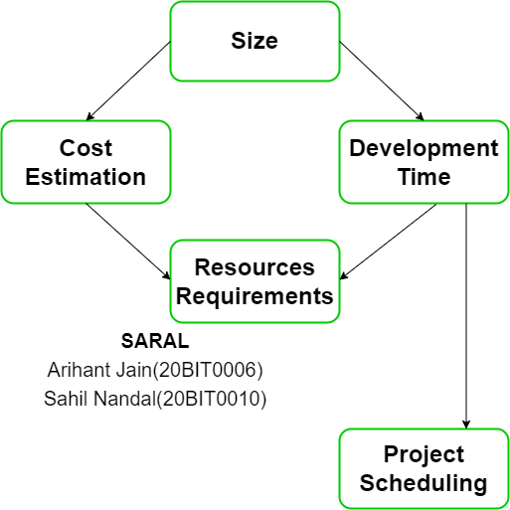

**Hardware & Software Requirements**

* **At Developer Side**

During system development, we have to design both static and dynamic website interfaces, create website functions and a database system, edit photos and pictures, so it has a set of software and hardware requirements.

## *Hardware Used*

* Intel Dual Core Processor
* O.S. (Windows 10 in our Project)

## *Software Used*

* WAMP SERVER
* Oracle SQL Plus Database
* NOTEPAD
* YED
* **At User Side**

The following are the requirements for the system users including members and administrators.

## *Hardware Requirements*

* Intel Processor
* O.S. (Windows 10 in our Project)

## *Software Requirements*

* Browser (We have used Google Chrome)
* Browser Must be JavaScript Enabled

**Details About Back End & Front End**

* **Back End Details**

The back-end part of the system is more important because it controls the entire internal processes of the system. We chose an Oracle database as the backend. This is because it is Word's most powerful relational database and more secure than any other database. SQL is a key part of WAMP (Window, Apache, MySQL, PHP), the fast-growing open-source enterprise software stack. More and more companies are using WAMP as an alternative to expensive proprietary software stacks because of its lower cost and freedom from platform lock-in.

* **Front End Details**

Front-end tools are used to provide a graphical user interface to the system. This makes the system more user-friendly and efficient. I chose PHP as the front-end tool. This is because it is an open-source technology that is freely available and familiar with all types of databases. We have chosen PHP since PHP is one of the most popular server-side scripting languages ​​today. It is used to interact with users and create dynamic web pages that provide custom information. PHP has many advantages. It's fast, stable, safe, easy to use, and open source (free).

* User friendly
* GUI
* Separation of work (designing & coding)
* Written once run anywhere
* PHP API

**Functional Requirements**

Functional requirements define the basic actions that software must perform when accepting inputs and processing and producing outputs. These are listed as "should" instructions, "The system is ....

* Login Module

This module is provided for administrators and users, such as buyers and sellers of products registered in the system. These logins are provided according to the needs of your system.

* **Input** - User ID and password
* **Process** - After user process enters the user ID and password, validation is performed to determine if the user ID and password are available in the database.
* **Output** - Registered users can access the website and use the service.
* Administrator Module

The administrator is provided with password and login-id with which he/she can access the system. Administrator is provided right of maintaining the database, verifies registered users.

* **Input** - User ID and password
* **Process** - After user process enters the user ID and password, validation is performed to determine if the user ID and password are available in the database.
* **Output** - Administrator will maintain the database and will perform Product seller process.
* Search Module

In this module we are going to provide facility for Product buyer to search for Products according to their specified categories so that users can search for Products easily.

* **Input -** Initial letter of Product, with the help of keywords and with the help of Brand name.
* **Output -** Information about Products.
* User Module

As users are the main visitor of site, the following facilities are available through this module.

* **Input** - User ID and password
* **Process** - After user process enters the user ID and password, validation is performed to determine if the user ID and password are available in the database.
* **Output** – Only genuine user can access the services provided by our online shopping portal.

**Entity Relationship Diagram**

Entity-relationship diagrams are one way to show the structure and layout of your database. This is often used to describe a database schema. ER diagrams are very useful because they provide a conceptual view of the database, regardless of the underlying hardware or software. ER Diagram is a model that identifies concepts or entities that exist in the system and the relationships between those entities. ER Diagram is often used to visualize relational databases. Each entity represents a database table, and the relationship line represents the key to the table that references a particular record in the related table.

ER Diagram can be more abstract because it doesn't necessarily capture all the tables needed by the database, but it helps to represent the most important concepts and relationships. This ER Diagram is the latter type and is designed to provide an abstract theoretical overview of the key entities and relationships needed to manage electronic resources. This helps the database design process of a resource management system, but it does not identify all the tables required for an electronic resource management database.

There are three main objects on an ER Diagram:

1. Entities
2. Relations
3. Attributes.

**Flowchart**

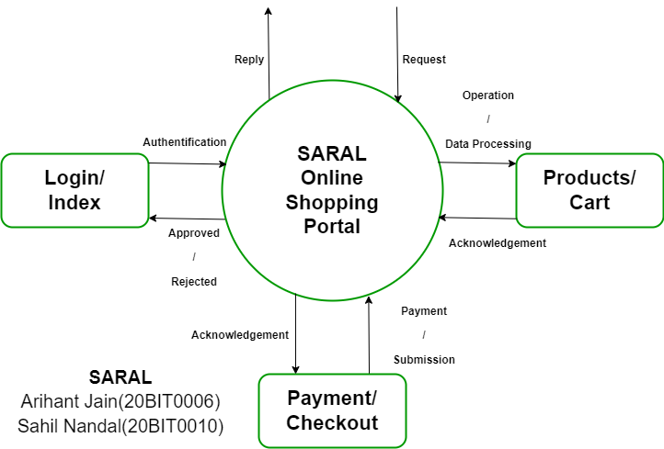

**For Registration**

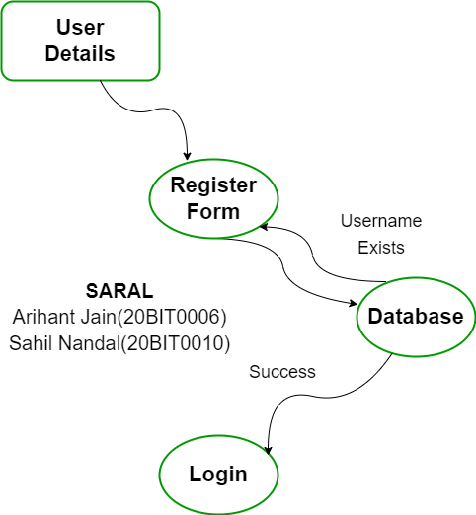**For Login**

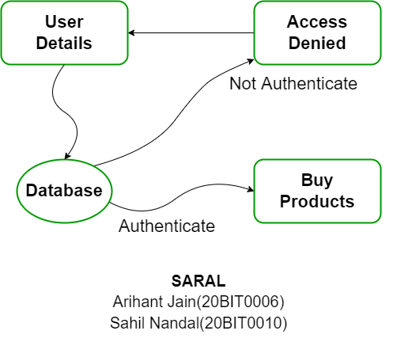

**For Buying Product**

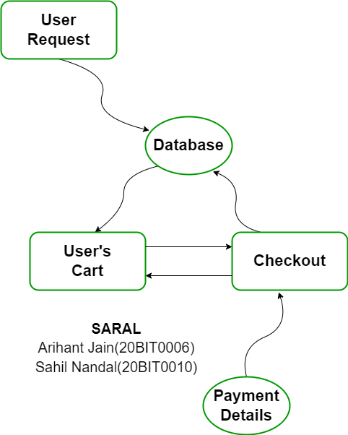

**Final ER Diagram**

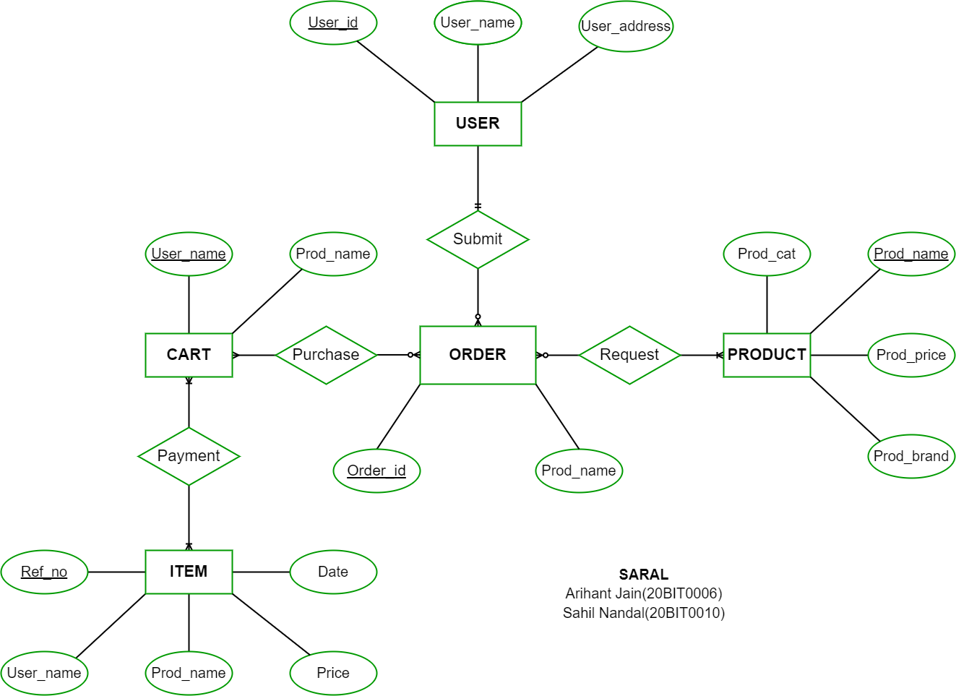

**Table Creation and Entries Using SQL**

**onlineshopping.sql**

SET SQL_MODE = "NO_AUTO_VALUE_ON_ZERO";

SET AUTOCOMMIT = 0;

START TRANSACTION;

SET time_zone = "+00:00";

DELIMITER $$

CREATE DEFINER=`root`@`localhost` PROCEDURE `getcat` (IN `cid` INT)  SELECT * FROM categories WHERE cat_id=cid$$

DELIMITER ;

CREATE TABLE `admin_info` (

  `admin_id` int(10) NOT NULL,

  `admin_name` varchar(100) NOT NULL,

  `admin_email` varchar(300) NOT NULL,

  `admin_password` varchar(300) NOT NULL

) ENGINE=InnoDB DEFAULT CHARSET=latin1;

INSERT INTO `admin_info` (`admin_id`, `admin_name`, `admin_email`, `admin_password`) VALUES

(1, 'admin', 'admin@gmail.com', '25f9e794323b453885f5181f1b624d0b');

CREATE TABLE `brands` (

  `brand_id` int(100) NOT NULL,

  `brand_title` text NOT NULL

) ENGINE=InnoDB DEFAULT CHARSET=latin1;

INSERT INTO `brands` (`brand_id`, `brand_title`) VALUES

(1, 'HP'),

(2, 'Samsung'),

(3, 'Apple'),

(4, 'motorolla'),

(5, 'LG'),

(6, 'Cloth Brand');

CREATE TABLE `cart` (

  `id` int(10) NOT NULL,

  `p_id` int(10) NOT NULL,

  `ip_add` varchar(250) NOT NULL,

  `user_id` int(10) DEFAULT NULL,

  `qty` int(10) NOT NULL

) ENGINE=InnoDB DEFAULT CHARSET=latin1;

INSERT INTO `cart` (`id`, `p_id`, `ip_add`, `user_id`, `qty`) VALUES

(6, 26, '::1', 4, 1),

(9, 10, '::1', 7, 1),

(10, 11, '::1', 7, 1),

(11, 45, '::1', 7, 1),

(44, 5, '::1', 3, 0),

(46, 2, '::1', 3, 0),

(48, 72, '::1', 3, 0),

(49, 60, '::1', 8, 1),

(50, 61, '::1', 8, 1),

(51, 1, '::1', 8, 1),

(52, 5, '::1', 9, 1),

(53, 2, '::1', 14, 1),

(54, 3, '::1', 14, 1),

(55, 5, '::1', 14, 1),

(56, 1, '::1', 9, 1),

(57, 2, '::1', 9, 1),

(71, 61, '127.0.0.1', -1, 1);

CREATE TABLE `categories` (

  `cat_id` int(100) NOT NULL,

  `cat_title` text NOT NULL

) ENGINE=InnoDB DEFAULT CHARSET=latin1;

INSERT INTO `categories` (`cat_id`, `cat_title`) VALUES

(1, 'Electronics'),

(2, 'Ladies Wears'),

(3, 'Mens Wear'),

(4, 'Kids Wear'),

(5, 'Furnitures'),

(6, 'Home Appliances'),

(7, 'Electronics Gadgets');

CREATE TABLE `email_info` (

  `email_id` int(100) NOT NULL,

  `email` text NOT NULL

) ENGINE=InnoDB DEFAULT CHARSET=latin1;

INSERT INTO `email_info` (`email_id`, `email`) VALUES

(3, 'admin@gmail.com'),

(4, 'puneethreddy951@gmail.com'),

(5, 'puneethreddy@gmail.com');

CREATE TABLE `logs` (

  `id` int(11) NOT NULL,

  `user_id` varchar(50) NOT NULL,

  `action` varchar(50) NOT NULL,

  `date` datetime NOT NULL

) ENGINE=InnoDB DEFAULT CHARSET=latin1;

CREATE TABLE `orders` (

  `order_id` int(11) NOT NULL,

  `user_id` int(11) NOT NULL,

  `product_id` int(11) NOT NULL,

  `qty` int(11) NOT NULL,

  `trx_id` varchar(255) NOT NULL,

  `p_status` varchar(20) NOT NULL

) ENGINE=InnoDB DEFAULT CHARSET=latin1;

INSERT INTO `orders` (`order_id`, `user_id`, `product_id`, `qty`, `trx_id`, `p_status`) VALUES

(1, 12, 7, 1, '07M47684BS5725041', 'Completed'),

(2, 14, 2, 1, '07M47684BS5725041', 'Completed');

CREATE TABLE `orders_info` (

  `order_id` int(10) NOT NULL,

  `user_id` int(11) NOT NULL,

  `f_name` varchar(255) NOT NULL,

  `email` varchar(255) NOT NULL,

  `address` varchar(255) NOT NULL,

  `city` varchar(255) NOT NULL,

  `state` varchar(255) NOT NULL,

  `zip` int(10) NOT NULL,

  `cardname` varchar(255) NOT NULL,

  `cardnumber` varchar(20) NOT NULL,

  `expdate` varchar(255) NOT NULL,

  `prod_count` int(15) DEFAULT NULL,

  `total_amt` int(15) DEFAULT NULL,

  `cvv` int(5) NOT NULL

) ENGINE=InnoDB DEFAULT CHARSET=latin1;

INSERT INTO `orders_info` (`order_id`, `user_id`, `f_name`, `email`, `address`, `city`, `state`, `zip`, `cardname`, `cardnumber`, `expdate`, `prod_count`, `total_amt`, `cvv`) VALUES

(1, 12, 'Puneeth', 'puneethreddy951@gmail.com', 'Bangalore, Kumbalagodu, Karnataka', 'Bangalore', 'Karnataka', 560074, 'pokjhgfcxc', '4321 2345 6788 7654', '12/90', 3, 77000, 1234);

CREATE TABLE `order_products` (

  `order_pro_id` int(10) NOT NULL,

  `order_id` int(11) NOT NULL,

  `product_id` int(11) NOT NULL,

  `qty` int(15) DEFAULT NULL,

  `amt` int(15) DEFAULT NULL

) ENGINE=InnoDB DEFAULT CHARSET=latin1;

INSERT INTO `order_products` (`order_pro_id`, `order_id`, `product_id`, `qty`, `amt`) VALUES

(73, 1, 1, 1, 5000),

(74, 1, 4, 2, 64000),

(75, 1, 8, 1, 40000);

CREATE TABLE `products` (

  `product_id` int(100) NOT NULL,

  `product_cat` int(100) NOT NULL,

  `product_brand` int(100) NOT NULL,

  `product_title` varchar(255) NOT NULL,

  `product_price` int(100) NOT NULL,

  `product_desc` text NOT NULL,

  `product_image` text NOT NULL,

  `product_keywords` text NOT NULL

) ENGINE=InnoDB DEFAULT CHARSET=latin1;

INSERT INTO `products` (`product_id`, `product_cat`, `product_brand`, `product_title`, `product_price`, `product_desc`, `product_image`, `product_keywords`) VALUES

(1, 1, 2, 'Samsung galaxy s7 edge', 5000, 'Samsung galaxy s7 edge', 'product07.png', 'samsung mobile electronics'),

(2, 1, 3, 'iPhone 5s', 25000, 'iphone 5s', 'http___pluspng.com_img-png_iphone-hd-png-iphone-apple-png-file-550.png', 'mobile iphone apple'),

(3, 1, 3, 'iPad air 2', 30000, 'ipad apple brand', 'da4371ffa192a115f922b1c0dff88193.png', 'apple ipad tablet'),

(4, 1, 3, 'iPhone 6s', 32000, 'Apple iPhone ', 'http___pluspng.com_img-png_iphone-6s-png-iphone-6s-gold-64gb-1000.png', 'iphone apple mobile'),

(5, 1, 2, 'iPad 2', 10000, 'samsung ipad', 'iPad-air.png', 'ipad tablet samsung'),

(6, 1, 1, 'samsung Laptop r series', 35000, 'samsung Black combination Laptop', 'laptop_PNG5939.png', 'samsung laptop '),

(7, 1, 1, 'Laptop Pavillion', 50000, 'Laptop Hp Pavillion', 'laptop_PNG5930.png', 'Laptop Hp Pavillion'),

(8, 1, 4, 'Sony', 40000, 'Sony Mobile', '530201353846AM_635_sony_xperia_z.png', 'sony mobile'),

(9, 1, 3, 'iPhone New', 12000, 'iphone', 'iphone-hd-png-iphone-apple-png-file-550.png', 'iphone apple mobile'),

(10, 2, 6, 'Red Ladies dress', 1000, 'red dress for girls', 'red dress.jpg', 'red dress '),

(11, 2, 6, 'Blue Heave dress', 1200, 'Blue dress', 'images.jpg', 'blue dress cloths'),

(12, 2, 6, 'Ladies Casual Cloths', 1500, 'ladies casual summer two colors pleted', '7475-ladies-casual-dresses-summer-two-colors-pleated.jpg', 'girl dress cloths casual'),

(13, 2, 6, 'SpringAutumnDress', 1200, 'girls dress', 'Spring-Autumn-Winter-Young-Ladies-Casual-Wool-Dress-Women-s-One-Piece-Dresse-Dating-Clothes-Medium.jpg_640x640.jpg', 'girl dress'),

(14, 2, 6, 'Casual Dress', 1400, 'girl dress', 'download.jpg', 'ladies cloths girl'),

(15, 2, 6, 'Formal Look', 1500, 'girl dress', 'shutterstock_203611819.jpg', 'ladies wears dress girl'),

(16, 3, 6, 'Sweter for men', 600, '2012-Winter-Sweater-for-Men-for-better-outlook', '2012-Winter-Sweater-for-Men-for-better-outlook.jpg', 'black sweter cloth winter'),

(17, 3, 6, 'Gents formal', 1000, 'gents formal look', 'gents-formal-250x250.jpg', 'gents wear cloths'),

(19, 3, 6, 'Formal Coat', 3000, 'ad', 'images (1).jpg', 'coat blazer gents'),

(20, 3, 6, 'Mens Sweeter', 1600, 'jg', 'Winter-fashion-men-burst-sweater.png', 'sweeter gents '),

(21, 3, 6, 'T shirt', 800, 'ssds', 'IN-Mens-Apparel-Voodoo-Tiles-09._V333872612_.jpg', 'formal t shirt black'),

(22, 4, 6, 'Yellow T shirt ', 1300, 'yello t shirt with pant', '1.0x0.jpg', 'kids yellow t shirt'),

(23, 4, 6, 'Girls cloths', 1900, 'sadsf', 'GirlsClothing_Widgets.jpg', 'formal kids wear dress'),

(24, 4, 6, 'Blue T shirt', 700, 'g', 'images.jpg', 'kids dress'),

(25, 4, 6, 'Yellow girls dress', 750, 'as', 'images (3).jpg', 'yellow kids dress'),

(27, 4, 6, 'Formal look', 690, 'sd', 'image28.jpg', 'formal kids dress'),

(32, 5, 0, 'Book Shelf', 2500, 'book shelf', 'furniture-book-shelf-250x250.jpg', 'book shelf furniture'),

(33, 6, 2, 'Refrigerator', 35000, 'Refrigerator', 'CT_WM_BTS-BTC-AppliancesHome_20150723.jpg', 'refrigerator samsung'),

(34, 6, 4, 'Emergency Light', 1000, 'Emergency Light', 'emergency light.JPG', 'emergency light'),

(35, 6, 0, 'Vaccum Cleaner', 6000, 'Vaccum Cleaner', 'images (2).jpg', 'Vaccum Cleaner'),

(36, 6, 5, 'Iron', 1500, 'gj', 'iron.JPG', 'iron'),

(37, 6, 5, 'LED TV', 20000, 'LED TV', 'images (4).jpg', 'led tv lg'),

(38, 6, 4, 'Microwave Oven', 3500, 'Microwave Oven', 'images.jpg', 'Microwave Oven'),

(39, 6, 5, 'Mixer Grinder', 2500, 'Mixer Grinder', 'singer-mixer-grinder-mg-46-medium_4bfa018096c25dec7ba0af40662856ef.jpg', 'Mixer Grinder'),

(40, 2, 6, 'Formal girls dress', 3000, 'Formal girls dress', 'girl-walking.jpg', 'ladies'),

(45, 1, 2, 'Samsung Galaxy Note 3', 10000, '0', 'samsung_galaxy_note3_note3neo.JPG', 'samsung galaxy Note 3 neo'),

(46, 1, 2, 'Samsung Galaxy Note 3', 10000, '', 'samsung_galaxy_note3_note3neo.JPG', 'samsung galxaxy note 3 neo'),

(47, 4, 6, 'Laptop', 650, 'nbk', 'product01.png', 'Dell Laptop'),

(48, 1, 7, 'Headphones', 250, 'Headphones', 'product05.png', 'Headphones Sony'),

(49, 1, 7, 'Headphones', 250, 'Headphones', 'product05.png', 'Headphones Sony'),

(50, 3, 6, 'boys shirts', 350, 'shirts', 'pm1.JPG', 'suit boys shirts'),

(51, 3, 6, 'boys shirts', 270, 'shirts', 'pm2.JPG', 'suit boys shirts'),

(52, 3, 6, 'boys shirts', 453, 'shirts', 'pm3.JPG', 'suit boys shirts'),

(53, 3, 6, 'boys shirts', 220, 'shirts', 'ms1.JPG', 'suit boys shirts'),

(54, 3, 6, 'boys shirts', 290, 'shirts', 'ms2.JPG', 'suit boys shirts'),

(55, 3, 6, 'boys shirts', 259, 'shirts', 'ms3.JPG', 'suit boys shirts'),

(56, 3, 6, 'boys shirts', 299, 'shirts', 'pm7.JPG', 'suit boys shirts'),

(57, 3, 6, 'boys shirts', 260, 'shirts', 'i3.JPG', 'suit boys shirts'),

(58, 3, 6, 'boys shirts', 350, 'shirts', 'pm9.JPG', 'suit boys shirts'),

(59, 3, 6, 'boys shirts', 855, 'shirts', 'a2.JPG', 'suit boys shirts'),

(60, 3, 6, 'boys shirts', 150, 'shirts', 'pm11.JPG', 'suit boys shirts'),

(61, 3, 6, 'boys shirts', 215, 'shirts', 'pm12.JPG', 'suit boys shirts'),

(62, 3, 6, 'boys shirts', 299, 'shirts', 'pm13.JPG', 'suit boys shirts'),

(63, 3, 6, 'boys Jeans Pant', 550, 'Pants', 'pt1.JPG', 'boys Jeans Pant'),

(64, 3, 6, 'boys Jeans Pant', 460, 'pants', 'pt2.JPG', 'boys Jeans Pant'),

(65, 3, 6, 'boys Jeans Pant', 470, 'pants', 'pt3.JPG', 'boys Jeans Pant'),

(66, 3, 6, 'boys Jeans Pant', 480, 'pants', 'pt4.JPG', 'boys Jeans Pant'),

(67, 3, 6, 'boys Jeans Pant', 360, 'pants', 'pt5.JPG', 'boys Jeans Pant'),

(68, 3, 6, 'boys Jeans Pant', 550, 'pants', 'pt6.JPG', 'boys Jeans Pant'),

(69, 3, 6, 'boys Jeans Pant', 390, 'pants', 'pt7.JPG', 'boys Jeans Pant'),

(70, 3, 6, 'boys Jeans Pant', 399, 'pants', 'pt8.JPG', 'boys Jeans Pant'),

(71, 1, 2, 'Samsung galaxy s7', 5000, 'Samsung galaxy s7', 'product07.png', 'samsung mobile electronics'),

(72, 7, 2, 'sony Headphones', 3500, 'sony Headphones', 'product02.png', 'sony Headphones electronics gadgets'),

(73, 7, 2, 'samsung Headphones', 3500, 'samsung Headphones', 'product05.png', 'samsung Headphones electronics gadgets'),

(74, 1, 1, 'HP i5 laptop', 5500, 'HP i5 laptop', 'product01.png', 'HP i5 laptop electronics'),

(75, 1, 1, 'HP i7 laptop 8gb ram', 5500, 'HP i7 laptop 8gb ram', 'product03.png', 'HP i7 laptop 8gb ram electronics'),

(76, 1, 5, 'sony note 6gb ram', 4500, 'sony note 6gb ram', 'product04.png', 'sony note 6gb ram mobile electronics'),

(77, 1, 4, 'MSV laptop 16gb ram NVIDEA Graphics', 5499, 'MSV laptop 16gb ram', 'product06.png', 'MSV laptop 16gb ram NVIDEA Graphics electronics'),

(78, 1, 5, 'dell laptop 8gb ram intel integerated Graphics', 4579, 'dell laptop 8gb ram intel integerated Graphics', 'product08.png', 'dell laptop 8gb ram intel integerated Graphics electronics'),

(79, 7, 2, 'camera with 3D pixels', 2569, 'camera with 3D pixels', 'product09.png', 'camera with 3D pixels camera electronics gadgets'),

(80, 1, 1, 'ytrfdkjsd', 12343, 'sdfhgh', '1542455446_thythtf .jpeg', 'dfgh'),

(81, 4, 6, 'Kids blue dress', 300, 'blue dress', '1543993724_pg4.jpg', 'kids blue dress');

CREATE TABLE `user_info` (

  `user_id` int(10) NOT NULL,

  `first_name` varchar(100) NOT NULL,

  `last_name` varchar(100) NOT NULL,

  `email` varchar(300) NOT NULL,

  `password` varchar(300) NOT NULL,

  `mobile` varchar(10) NOT NULL,

  `address1` varchar(300) NOT NULL,

  `address2` varchar(11) NOT NULL

) ENGINE=InnoDB DEFAULT CHARSET=latin1;

INSERT INTO `user_info` (`user_id`, `first_name`, `last_name`, `email`, `password`, `mobile`, `address1`, `address2`) VALUES

(12, 'puneeth', 'Reddy', 'puneethreddy951@gmail.com', 'puneeth', '9448121558', '123456789', 'sdcjns,djc'),

(15, 'hemu', 'ajhgdg', 'puneethreddy951@gmail.com', '346778', '536487276', ',mdnbca', 'asdmhmhvbv'),

(16, 'venky', 'vs', 'venkey@gmail.com', '1234534', '9877654334', 'snhdgvajfehyfygv', 'asdjbhfkeur'),

(19, 'abhishek', 'bs', 'abhishekbs@gmail.com', 'asdcsdcc', '9871236534', 'bangalore', 'hassan'),

(21, 'prajval', 'mcta', 'prajvalmcta@gmail.com', '1234545662', '202-555-01', 'bangalore', 'kumbalagodu'),

(22, 'puneeth', 'v', 'hemu@gmail.com', '1234534', '9877654334', 'snhdgvajfehyfygv', 'asdjbhfkeur'),

(23, 'hemanth', 'reddy', 'hemanth@gmail.com', 'Puneeth@123', '9876543234', 'Bangalore', 'Kumbalagodu'),

(24, 'newuser', 'user', 'newuser@gmail.com', 'puneeth@123', '9535688928', 'Bangalore', 'Kumbalagodu'),

(25, 'otheruser', 'user', 'otheruser@gmail.com', 'puneeth@123', '9535688928', 'Bangalore', 'Kumbalagodu');

DELIMITER $$

CREATE TRIGGER `after_user_info_insert` AFTER INSERT ON `user_info` FOR EACH ROW BEGIN

INSERT INTO user_info_backup VALUES(new.user_id,new.first_name,new.last_name,new.email,new.password,new.mobile,new.address1,new.address2);

END

$$

DELIMITER ;

CREATE TABLE `user_info_backup` (

  `user_id` int(10) NOT NULL,

  `first_name` varchar(100) NOT NULL,

  `last_name` varchar(100) NOT NULL,

  `email` varchar(300) NOT NULL,

  `password` varchar(300) NOT NULL,

  `mobile` varchar(10) NOT NULL,

  `address1` varchar(300) NOT NULL,

  `address2` varchar(11) NOT NULL

) ENGINE=InnoDB DEFAULT CHARSET=latin1;

INSERT INTO `user_info_backup` (`user_id`, `first_name`, `last_name`, `email`, `password`, `mobile`, `address1`, `address2`) VALUES

(12, 'puneeth', 'Reddy', 'puneethreddy951@gmail.com', '123456789', '9448121558', '123456789', 'sdcjns,djc'),

(14, 'hemanthu', 'reddy', 'hemanthreddy951@gmail.com', '123456788', '6526436723', 's,dc wfjvnvn', 'b efhfhvvbr'),

(15, 'hemu', 'ajhgdg', 'keeru@gmail.com', '346778', '536487276', ',mdnbca', 'asdmhmhvbv'),

(16, 'venky', 'vs', 'venkey@gmail.com', '1234534', '9877654334', 'snhdgvajfehyfygv', 'asdjbhfkeur'),

(19, 'abhishek', 'bs', 'abhishekbs@gmail.com', 'asdcsdcc', '9871236534', 'bangalore', 'hassan'),

(20, 'pramod', 'vh', 'pramod@gmail.com', '124335353', '9767645653', 'ksbdfcdf', 'sjrgrevgsib'),

(21, 'prajval', 'mcta', 'prajvalmcta@gmail.com', '1234545662', '202-555-01', 'bangalore', 'kumbalagodu'),

(22, 'puneeth', 'v', 'hemu@gmail.com', '1234534', '9877654334', 'snhdgvajfehyfygv', 'asdjbhfkeur'),

(23, 'hemanth', 'reddy', 'hemanth@gmail.com', 'Puneeth@123', '9876543234', 'Bangalore', 'Kumbalagodu'),

(24, 'newuser', 'user', 'newuser@gmail.com', 'puneeth@123', '9535688928', 'Bangalore', 'Kumbalagodu'),

(25, 'otheruser', 'user', 'otheruser@gmail.com', 'puneeth@123', '9535688928', 'Bangalore', 'Kumbalagodu');

ALTER TABLE `admin_info`

  ADD PRIMARY KEY (`admin_id`);

ALTER TABLE `brands`

  ADD PRIMARY KEY (`brand_id`);

ALTER TABLE `cart`

  ADD PRIMARY KEY (`id`);

ALTER TABLE `categories`

  ADD PRIMARY KEY (`cat_id`);

ALTER TABLE `email_info`

  ADD PRIMARY KEY (`email_id`);

ALTER TABLE `logs`

  ADD PRIMARY KEY (`id`);

ALTER TABLE `orders`

  ADD PRIMARY KEY (`order_id`);

ALTER TABLE `orders_info`

  ADD PRIMARY KEY (`order_id`),

  ADD KEY `user_id` (`user_id`);

ALTER TABLE `order_products`

  ADD PRIMARY KEY (`order_pro_id`),

  ADD KEY `order_products` (`order_id`),

  ADD KEY `product_id` (`product_id`);

ALTER TABLE `products`

  ADD PRIMARY KEY (`product_id`);

ALTER TABLE `user_info`

  ADD PRIMARY KEY (`user_id`);

ALTER TABLE `user_info_backup`

  ADD PRIMARY KEY (`user_id`);

ALTER TABLE `admin_info`

  MODIFY `admin_id` int(10) NOT NULL AUTO_INCREMENT, AUTO_INCREMENT=2;

ALTER TABLE `brands`

  MODIFY `brand_id` int(100) NOT NULL AUTO_INCREMENT, AUTO_INCREMENT=7;

ALTER TABLE `cart`

  MODIFY `id` int(10) NOT NULL AUTO_INCREMENT, AUTO_INCREMENT=147;

ALTER TABLE `categories`

  MODIFY `cat_id` int(100) NOT NULL AUTO_INCREMENT, AUTO_INCREMENT=8;

ALTER TABLE `email_info`

  MODIFY `email_id` int(100) NOT NULL AUTO_INCREMENT, AUTO_INCREMENT=6;

ALTER TABLE `logs`

  MODIFY `id` int(11) NOT NULL AUTO_INCREMENT;

ALTER TABLE `orders`

  MODIFY `order_id` int(11) NOT NULL AUTO_INCREMENT, AUTO_INCREMENT=3;

ALTER TABLE `orders_info`

  MODIFY `order_id` int(10) NOT NULL AUTO_INCREMENT, AUTO_INCREMENT=16;

ALTER TABLE `order_products`

  MODIFY `order_pro_id` int(10) NOT NULL AUTO_INCREMENT, AUTO_INCREMENT=91;

ALTER TABLE `products`

  MODIFY `product_id` int(100) NOT NULL AUTO_INCREMENT, AUTO_INCREMENT=82;

ALTER TABLE `user_info`

  MODIFY `user_id` int(10) NOT NULL AUTO_INCREMENT, AUTO_INCREMENT=26;

ALTER TABLE `user_info_backup`

  MODIFY `user_id` int(10) NOT NULL AUTO_INCREMENT, AUTO_INCREMENT=26;

ALTER TABLE `orders_info`

  ADD CONSTRAINT `user_id` FOREIGN KEY (`user_id`) REFERENCES `user_info` (`user_id`);

ALTER TABLE `order_products`

  ADD CONSTRAINT `order_products` FOREIGN KEY (`order_id`) REFERENCES `orders_info` (`order_id`) ON DELETE NO ACTION ON UPDATE CASCADE,

  ADD CONSTRAINT `product_id` FOREIGN KEY (`product_id`) REFERENCES `products` (`product_id`);

COMMIT;

**Front End Using PHP & CSS**

**index.php**

**<?php**

**include "header.php";**

**include "body.php";**

**include "footer.php";**

**?>**

**body.php**

**include 'db.php';**

**$product_query = "SELECT * FROM products,categories WHERE product_cat=cat_id AND product_id BETWEEN 70 AND 75";**

**$run_query = mysqli_query($con,$product_query);**

**if(mysqli_num_rows($run_query) > 0){**

**while($row = mysqli_fetch_array($run_query)){**

**$pro_id    = $row['product_id'];**

**$pro_cat   = $row['product_cat'];**

**$pro_brand = $row['product_brand'];**

**$pro_title = $row['product_title'];**

**$pro_price = $row['product_price'];**

**$pro_image = $row['product_image'];**

**$cat_name = $row["cat_title"];**

**echo "**

**<div class='product'>**

**<a href='product.php?p=$pro_id'><div class='product-img'>**

**<img src='product_images/$pro_image' style='max-height: 170px;' alt=''>**

**<div class='product-label'>**

**</div>**

**</div></a>**

**<div class='product-body'>**

**<p class='product-category'>$cat_name</p>**

**<h3 class='product-name header-cart-item-name'><a href='product.php?p=$pro_id'>$pro_title</a></h3>**

**<h4 class='product-price header-cart-item-info'>$pro_price<del class='product-old-price'>$990.00</del></h4>**

**<div class='product-rating'>**

**<i class='fa fa-star'></i>**

**<i class='fa fa-star'></i>**

**<i class='fa fa-star'></i>**

**<i class='fa fa-star'></i>**

**<i class='fa fa-star'></i>**

**</div>**

**<div class='product-btns'>**

**<button class='add-to-wishlist'><i class='fa fa-heart-o'></i><span class='tooltipp'>add to wishlist</span></button>**

**<button class='add-to-compare'><i class='fa fa-exchange'></i><span class='tooltipp'>add to compare</span></button>**

**<button class='quick-view'><i class='fa fa-eye'></i><span class='tooltipp'>quick view</span></button>**

**</div>**

**</div>**

**<div class='add-to-cart'>**

**<button pid='$pro_id' id='product' class='add-to-cart-btn block2-btn-towishlist' href='#'><i class='fa fa-shopping-cart'></i> add to cart</button>**

**</div>**

**</div>**

**";**

**}**

**;**

**}**

**?>**

**</div>**

**<div id="slick-nav-1" class="products-slick-nav"></div>**

**</div>**

**</div>**

**</div>**

**</div>**

**</div>**

**</div>**

**</div>**

**<div class="product-widget">**

**<div class="product-img">**

**<img src="./img/product05.png" alt="">**

**</div>**

**<div class="product-body">**

**<p class="product-category">Category</p>**

**<h3 class="product-name"><a href="#">product name goes here</a></h3>**

**<h4 class="product-price">980.00 <del class="product-old-price">990.00</del></h4>**

**</div>**

**</div>**

**<div class="product-widget">**

**<div class="product-img">**

**<img src="./img/product06.png" alt="">**

**</div>**

**<div class="product-body">**

**<p class="product-category">Category</p>**

**<h3 class="product-name"><a href="#">product name goes here</a></h3>**

**<h4 class="product-price">980.00 <del class="product-old-price">990.00</del></h4>**

**</div>**

**</div>**

**</div>**

**<div>**

**<div class="product-widget">**

**<div class="product-img">**

**<img src="./img/product07.png" alt="">**

**</div>**

**<div class="product-body">**

**<p class="product-category">Category</p>**

**<h3 class="product-name"><a href="#">product name goes here</a></h3>**

**<h4 class="product-price">980.00 <del class="product-old-price">990.00</del></h4>**

**</div>**

**</div>**

**<div class="product-widget">**

**<div class="product-img">**

**<img src="./img/product08.png" alt="">**

**</div>**

**<div class="product-body">**

**<p class="product-category">Category</p>**

**<h3 class="product-name"><a href="#">product name goes here</a></h3>**

**<h4 class="product-price">980.00 <del class="product-old-price">990.00</del></h4>**

**</div>**

**</div>**

**<div class="product-widget">**

**<div class="product-img">**

**<img src="./img/product09.png" alt="">**

**</div>**

**<div class="product-body">**

**<p class="product-category">Category</p>**

**<h3 class="product-name"><a href="#">product name goes here</a></h3>**

**<h4 class="product-price">980.00 <del class="product-old-price">990.00</del></h4>**

**</div>**

**</div>**

**</div>**

**</div>**

**</div>**

**<div class="clearfix visible-sm visible-xs">**

**</div>**

**<div class="col-md-4 col-xs-6">**

**<div class="products-widget-slick" data-nav="#slick-nav-5">**

**<div>**

**<div class="product-widget">**

**<div class="product-img">**

**<img src="./img/product01.png" alt="">**

**</div>**

**<div class="product-body">**

**<p class="product-category">Category</p>**

**<h3 class="product-name"><a href="#">product name goes here</a></h3>**

**<h4 class="product-price">980.00 <del class="product-old-price">990.00</del></h4>**

**</div>**

**</div>**

**<div class="product-widget">**

**<div class="product-img">**

**<img src="./img/product02.png" alt="">**

**</div>**

**<div class="product-body">**

**<p class="product-category">Category</p>**

**<h3 class="product-name"><a href="#">product name goes here</a></h3>**

**<h4 class="product-price">980.00 <del class="product-old-price">990.00</del></h4>**

**</div>**

**</div>**

**<div class="product-widget">**

**<div class="product-img">**

**<img src="./img/product03.png" alt="">**

**</div>**

**<div class="product-body">**

**<p class="product-category">Category</p>**

**<h3 class="product-name"><a href="#">product name goes here</a></h3>**

**<h4 class="product-price">980.00 <del class="product-old-price">90.00</del></h4>**

**</div>**

**</div>**

**</div>**

**<div>**

**<div class="product-widget">**

**<div class="product-img">**

**<img src="./img/product04.png" alt="">**

**</div>**

**<div class="product-body">**

**<p class="product-category">Category</p>**

**<h3 class="product-name"><a href="#">product name goes here</a></h3>**

**<h4 class="product-price">980.00 <del class="product-old-price">990.00</del></h4>**

**</div>**

**</div>**

**<div class="product-widget">**

**<div class="product-img">**

**<img src="./img/product05.png" alt="">**

**</div>**

**<div class="product-body">**

**<p class="product-category">Category</p>**

**<h3 class="product-name"><a href="#">product name goes here</a></h3>**

**<h4 class="product-price">980.00 <del class="product-old-price">990.00</del></h4>**

**</div>**

**</div>**

**<div class="product-widget">**

**<div class="product-img">**

**<img src="./img/product06.png" alt="">**

**</div>**

**<div class="product-body">**

**<p class="product-category">Category</p>**

**<h3 class="product-name"><a href="#">product name goes here</a></h3>**

**<h4 class="product-price">980.00 <del class="product-old-price">990.00</del></h4>**

**</div>**

**</div>**

**</div>**

**</div>**

**</div>**

**</div>**

**</div>**

**</div>**

**</div>**

**header.php**

**<?php**

**session_start();**

**?>**

**<!DOCTYPE html>**

**<html lang="en">**

**<head>**

**<meta charset="utf-8">**

**<meta http-equiv="X-UA-Compatible" content="IE=edge">**

**<meta name="viewport" content="width=device-width, initial-scale=1">**

**<title>Saral Online Shopping System</title>**

**<link type="text/css" rel="stylesheet" href="css/bootstrap.min.css"/>**

**<link rel="stylesheet" href="style.css">**

**<style>**

**body{**

**background-color: green;**

**width: 100%;**

**}**

**#navigation {**

**background: rgba(26, 155, 0, 0.911);**

**}**

**#header {**

**background: green;**

**}**

**#top-header {**

**padding-top: 1px;**

**padding-bottom: 1px;**

**background: green;**

**}**

**#footer {**

**background: rgba(26, 130, 0, 0.811);**

**color: #1E1F29;**

**}**

**#bottom-footer {**

**background: rgba(26, 130, 0, 0.811);**

**}**

**.mainn-raised {**

**margin: -7px 5px 5px;**

**}**

**</style>**

**</head>**

**<body>**

**<!-- HEADER -->**

**<header>**

**<!-- TOP HEADER -->**

**<div id="top-header">**

**<div class="container">**

**<ul class="header-links pull-right">**

**<li><?php**

**include "db.php";**

**if(isset($_SESSION["uid"])){**

**$sql = "SELECT first_name FROM user_info WHERE user_id='$_SESSION[uid]'";**

**$query = mysqli_query($con,$sql);**

**$row=mysqli_fetch_array($query);**

**echo '**

**<div class="dropdownn">**

**<a href="#" class="dropdownn" data-toggle="modal" data-target="#myModal" ><i class="fa fa-user-o"></i> HI '.$row["first_name"].'</a>**

**<div class="dropdownn-content">**

**<a href="logout.php"  ><i class="fa fa-sign-in" aria-hidden="true"></i>Log out</a>**

**</div>**

**</div>';**

**}else{**

**echo '**

**<div class="dropdownn">**

**<a href="#" class="dropdownn" data-toggle="modal" data-target="#myModal" ><i class="fa fa-user-o"></i> My Account</a>**

**<div class="dropdownn-content">**

**<a href="" data-toggle="modal" data-target="#Modal_login"><i class="fa fa-sign-in" aria-hidden="true" ></i>Login</a>**

**<a href="" data-toggle="modal" data-target="#Modal_register"><i class="fa fa-user-plus" aria-hidden="true"></i>Register</a>**

**</div>**

**</div>';**

**}**

**?>**

**</li>**

**</ul>**

**</div>**

**</div>**

**<div id="header">**

**<div class="container">**

**<div class="row">**

**<div class="col-md-3">**

**<div style="width: 2000px" class="header-logo">**

**<font style="font-style:normal; font-size: 40px;color: aliceblue;font-family: Time New Roman">**

**<u> Saral Online Shopping System </u>**

**</font>**

**</div>**

**</div>**

**<div class="col-md-6">**

**</div>**

**<div class="col-md-3 clearfix">**

**<div class="header-ctn">**

**<div class="dropdown">**

**<a class="dropdown-toggle" data-toggle="dropdown" aria-expanded="true">**

**<i class="fa fa-shopping-cart"></i>**

**<span>Cart</span>**

**<div class="badge qty">0</div>**

**</a>**

**<div class="cart-dropdown"  >**

**<div class="cart-btns">**

**<a href="cart.php" style="width:100%;">  Edit </a>**

**</div>**

**</div>**

**</div>**

**<div class="menu-toggle">**

**<a href="#">**

**<i class="fa fa-bars"></i>**

**<span>Menu</span>**

**</a>**

**</div>**

**</div>**

**</div>**

**</div>**

**</div>**

**</div>**

**</header>**

**<nav id='navigation'>**

**<div class="container" id="get_category_home">**

**</div>**

**</nav>**

**<div class="modal fade" id="Modal_login" role="dialog">**

**<div class="modal-dialog">**

**<div class="modal-content">**

**<div class="modal-header">**

**<button type="button" class="close" data-dismiss="modal">&times;</button>**

**</div>**

**<div class="modal-body">**

**<?php**

**include "login_form.php";**

**?>**

**</div>**

**</div>**

**</div>**

**</div>**

**<div class="modal fade" id="Modal_register" role="dialog">**

**<div class="modal-dialog" style="">**

**<div class="modal-content">**

**<div class="modal-header">**

**<button type="button" class="close" data-dismiss="modal">&times;</button>**

**</div>**

**<div class="modal-body">**

**<?php**

**include "register_form.php";**

**?>**

**</div>**

**</div>**

**</div>**

**</div>**

**footer.php**

**<footer id="footer">**

**<div class="section"**

**<div class="container">**

**<div class="row">**

**<div class="col-md-3 col-xs-6">**

**<div class="footer">**

**<h3 class="footer-title">About Us</h3>**

**<ul class="footer-links">**

**<li>SAHIL NANDAL (sahil.nandal2020@vitstudent.ac.in)</li>**

**<li>ARIHANT JAIN (arihant.jain2020@vitstudent.ac.in)</li>**

**</ul>**

**</div>**

**</div>**

**<div class="col-md-3 col-xs-6">**

**<div class="footer">**

**'SARAL Online Shopping' is a web application. It provides a platform that aims to create a link between sellers and buyers with the help of the Internet. The main aim is to reduce the adverse effect that impacts the local sellers in the era of Amazon, Flipkart, etc.**

**It will help the retailers and wholesalers to set up their businesses(shops) and display their products with ease to sell. It will also provide the consumers or buyers an opportunity to go through a variety of products and then choose what suits them best, without having to visit the shops physically**

**</div>**

**</div>**

**</div>**

**</div>**

**</div>**

**</footer>**

**<script src="js/jquery.min.js"></script>**

**<script src="js/main.js"></script>**

**<script src="js/script.js"></script>**

**<script>var c = 0;**

**function menu(){**

**if(c % 2 == 0) {**

**document.querySelector('.cont_drobpdown_menu').className = "cont_drobpdown_menu active";**

**document.querySelector('.cont_icon_trg').className = "cont_icon_trg active";**

**c++;**

**}else{**

**document.querySelector('.cont_drobpdown_menu').className = "cont_drobpdown_menu disable";**

**document.querySelector('.cont_icon_trg').className = "cont_icon_trg disable";**

**c++;**

**}**

**}**

**</script>**

**<script type="text/javascript">**

**$('.block2-btn-addcart').each(function(){**

**var nameProduct = $(this).parent().parent().parent().find('.block2-name').html();**

**$(this).on('click', function(){**

**swal(nameProduct, "is added to cart !", "success");**

**});**

**});**

**$('.block2-btn-addwishlist').each(function(){**

**var nameProduct = $(this).parent().parent().parent().find('.block2-name').html();**

**$(this).on('click', function(){**

**swal(nameProduct, "is added to wishlist !", "success");**

**});**

**});**

**</script>**

**login_form.php**

**<?php**

**if (isset($_POST["login_user_with_product"])) {**

**$product_list = $_POST["product_id"];**

**$json_e = json_encode($product_list);**

**setcookie("product_list",$json_e,strtotime("+1 day"),"/","","",TRUE);**

**}**

**?>**

**<div class="wait overlay">**

**<div class="loader"></div>**

**</div>**

**<div class="container-fluid">**

**<div class="login-marg">**

**<form onsubmit="return false" id="login" class="login100-form ">**

**<div class="billing-details jumbotron">**

**<div class="section-title">**

**<h2 class="login100-form-title p-b-49" >Login Here</h2>**

**</div>**

**<div class="form-group">**

**<label for="email">Email</label>**

**<input class="input input-borders" type="email" name="email" placeholder="Email" id="password" required>**

**</div>**

**<div class="form-group">**

**<label for="email">Password</label>**

**<input class="input input-borders" type="password" name="password" placeholder="password" id="password" required>**

**</div>**

**<div class="text-pad" >**

**<a href="#">**

**forget password ?**

**</a>**

**</div>**

**<input class="primary-btn btn-block"   type="submit"  Value="Login">**

**<div class="panel-footer"><div class="alert alert-danger"><h4 id="e_msg"></h4></div></div>**

**</div>**

**</form>**

**</div>**

**</div>**

**signup_form.php**

**<div class="wait overlay">**

**<div class="loader"></div>**

**</div>**

**<style>**

**.input-borders{**

**border-radius:30px;**

**}**

**</style>**

**<!-- row -->**

**<div class="container-fluid">**

**<!-- /Billing Details -->**

**<form id="signup_form" onsubmit="return false" class="login100-form">**

**<div class="billing-details jumbotron">**

**<div class="section-title">**

**<h2 class="login100-form-title p-b-49" >Register Here</h2>**

**</div>**

**<div class="form-group ">**

**<input class="input form-control input-borders" type="text" name="f_name" id="f_name" placeholder="First Name">**

**</div>**

**<div class="form-group">**

**<input class="input form-control input-borders" type="text" name="l_name" id="l_name" placeholder="Last Name">**

**</div>**

**<div class="form-group">**

**<input class="input form-control input-borders" type="email" name="email"  placeholder="Email">**

**</div>**

**<div class="form-group">**

**<input class="input form-control input-borders" type="password" name="password" id="password" placeholder="password">**

**</div>**

**<div class="form-group">**

**<input class="input form-control input-borders" type="password" name="repassword" id="repassword" placeholder="confirm password">**

**</div>**

**<div class="form-group">**

**<input class="input form-control input-borders" type="text" name="mobile" id="mobile" placeholder="mobile">**

**</div>**

**<div class="form-group">**

**<input class="input form-control input-borders" type="text" name="address1" id="address1" placeholder="Address">**

**</div>**

**<div class="form-group">**

**<input class="input form-control input-borders" type="text" name="address2" id="address2" placeholder="City">**

**</div>**

**<div style="form-group">**

**<input class="primary-btn btn-block"  value="Sign Up" type="submit" name="signup_button">**

**</div>**

**<div class="text-pad">**

**<a href="" data-toggle="modal" data-target="#Modal_login">Already have an Account ? then login</a>**

**</div>**

**</form>**

**<div class="login-marg">**

**<!-- Billing Details -->**

**<div class="row">**

**<div class="col-md-2"></div>**

**<div class="col-md-8" id="signup_msg">**

**</div>**

**<!--Alert from signup form-->**

**</div>**

**<div class="col-md-2"></div>**

**</div>**

**</div>**

**</div>**

**style.css**

**body {**

**font-family: 'Montserrat', sans-serif;**

**font-weight: 400;**

**}**

**h1, h2, h3, h4, h5, h6 {**

**color: #2B2D42;**

**font-weight: 700;**

**margin: 0 0 10px;**

**}**

**a {**

**color: #2B2D42;**

**font-weight: 500;**

**-webkit-transition: 0.2s color;**

**transition: 0.2s color;**

**}**

**a:hover, a:focus {**

**color: #D10024;**

**text-decoration: none;**

**outline: none;**

**}**

**ul, ol {**

**margin: 0;**

**padding: 0;**

**list-style: none**

**}**

**/*----------------------------\*\**

**Buttons**

**\*----------------------------*/**

**.primary-btn {**

**display: inline-block;**

**padding: 12px 30px;**

**background-color: #5ed100;**

**border: none;**

**color: #FFF;**

**text-transform: uppercase;**

**font-weight: 700;**

**text-align: center;**

**}**

**.primary-btn:hover, .primary-btn:focus {**

**opacity: 0.9;**

**color: #FFF;**

**}**

**.section {**

**padding-top: 30px;**

**padding-bottom: 30px;**

**}**

**.section-title {**

**position: relative;**

**margin-bottom: 30px;**

**margin-top: 15px;**

**}**

**.section-title .title {**

**display: inline-block;**

**text-transform: uppercase;**

**margin: 0px;**

**}**

**.section-title .section-nav {**

**float: right;**

**}**

**.section-title .section-nav .section-tab-nav {**

**display: inline-block;**

**}**

**.section-tab-nav li {**

**display: inline-block;**

**margin-right: 15px;**

**}**

**.section-tab-nav li:last-child {**

**margin-right: 0px;**

**}**

**.section-tab-nav li a {**

**font-weight: 700;**

**color: #8D99AE;**

**}**

**.section-tab-nav li a:after {**

**content: "";**

**display: block;**

**width: 0%;**

**height: 2px;**

**background-color: #D10024;**

**-webkit-transition: 0.2s all;**

**transition: 0.2s all;**

**}**

**.section-tab-nav li.active a {**

**color: #D10024;**

**}**

**.section-tab-nav li a:hover:after, .section-tab-nav li a:focus:after, .section-tab-nav li.active a:after {**

**width: 100%;**

**}**

**.section-title .section-nav .products-slick-nav {**

**top: 0px;**

**right: 0px;**

**}**

**#top-header {**

**padding-top: 10px;**

**padding-bottom: 5px;**

**background-color: #1E1F29;**

**}**

**.header-links li {**

**display: inline-block;**

**margin-right: 15px;**

**font-size: 20px;**

**}**

**.header-links li:last-child {**

**margin-right: 0px;**

**}**

**.header-links li a {**

**color: #FFF;**

**}**

**.header-links li a:hover {**

**color: #D10024;**

**}**

**.header-links li i {**

**color: #D10024;**

**margin-right: 5px;**

**}**

**/*----------------------------\*\**

**Logo**

**\*----------------------------*/**

**#header {**

**padding-top: 15px;**

**padding-bottom: 15px;**

**}**

**.header-logo {**

**float: left;**

**}**

**.header-logo .logo img {**

**display: block;**

**}**

**.header-ctn {**

**float: right;**

**padding: 15px 0px;**

**}**

**.header-ctn>div {**

**display: inline-block;**

**}**

**.header-ctn>div+div {**

**margin-left: 15px;**

**}**

**.header-ctn>div>a {**

**display: block;**

**position: relative;**

**width: 90px;**

**text-align: center;**

**color: #FFF;**

**}**

**.header-ctn>div>a>i {**

**display: block;**

**font-size: 18px;**

**}**

**.header-ctn>div>a>span {**

**font-size: 12px;**

**}**

**.header-ctn>div>a>.qty {**

**position: absolute;**

**right: 15px;**

**top: -10px;**

**width: 20px;**

**height: 20px;**

**line-height: 20px;**

**text-align: center;**

**border-radius: 50%;**

**font-size: 10px;**

**color: #FFF;**

**background-color: #D10024;**

**}**

**.header-ctn .menu-toggle {**

**display: none;**

**}**

**.product {**

**position: relative;**

**margin: 15px 0px;**

**-webkit-box-shadow: 0px 0px 0px 0px #E4E7ED, 0px 0px 0px 1px #E4E7ED;**

**box-shadow: 0px 0px 0px 0px #E4E7ED, 0px 0px 0px 1px #E4E7ED;**

**-webkit-transition: 0.2s all;**

**transition: 0.2s all;**

**}**

**.product .product-img {**

**position: relative;**

**}**

**.product .product-img>img {**

**width: 50%;**

**}**

**.product .product-img .product-label {**

**position: absolute;**

**top: 15px;**

**right: 15px;**

**}**

**.product .product-img .product-label>span {**

**border: 2px solid;**

**padding: 2px 10px;**

**font-size: 12px;**

**}**

**.product .product-img .product-label>span.sale {**

**display: none;**

**background-color: #FFF;**

**border-color: #D10024;**

**color: #D10024;**

**}**

**.product .product-img .product-label>span.new {**

**display: none;**

**background-color: #D10024;**

**border-color: #D10024;**

**color: #FFF;**

**}**

**.product .product-body {**

**position: relative;**

**padding: 15px;**

**background-color: #FFF;**

**text-align: center;**

**z-index: 20;**

**}**

**.product .product-body .product-category {**

**text-transform: uppercase;**

**font-size: 12px;**

**color: #8D99AE;**

**}**

**.product .product-body .product-name {**

**text-transform: uppercase;**

**font-size: 14px;**

**}**

**.product .product-body .product-name>a {**

**font-weight: 700;**

**}**

**.product .product-body .product-name>a:hover, .product .product-body .product-name>a:focus {**

**color: #00d11c;**

**}**

**.product .product-body .product-price {**

**color: #00d100;**

**font-size: 18px;**

**}**

**.product .product-body .product-price .product-old-price {**

**display: none;**

**font-size: 70%;**

**font-weight: 400;**

**color: #8D99AE;**

**}**

**.product .product-body .product-rating {**

**position: relative;**

**margin: 15px 0px 10px;**

**height: 20px;**

**}**

**.product .product-body .product-rating>i {**

**position: relative;**

**width: 14px;**

**margin-right: -4px;**

**background: #FFF;**

**color: #E4E7ED;**

**z-index: 10;**

**}**

**.product .product-body .product-rating>i.fa-star {**

**color: #23ef45;**

**}**

**.product .product-body .product-rating:after {**

**content: "";**

**position: absolute;**

**top: 50%;**

**left: 0;**

**right: 0;**

**-webkit-transform: translateY(-50%);**

**-ms-transform: translateY(-50%);**

**transform: translateY(-50%);**

**height: 1px;**

**background-color: #51fd2e;**

**}**

**.product .product-body .product-btns>button {**

**position: relative;**

**width: 40px;**

**height: 40px;**

**line-height: 40px;**

**background: transparent;**

**border: none;**

**-webkit-transition: 0.2s all;**

**transition: 0.2s all;**

**}**

**.product .product-body .product-btns>button:hover {**

**background-color: #E4E7ED;**

**color: #2ad100;**

**border-radius: 1%;**

**}**

**.product .product-body .product-btns>button .tooltipp {**

**position: absolute;**

**bottom: 100%;**

**left: 50%;**

**-webkit-transform: translate(-50%, -15px);**

**-ms-transform: translate(-50%, -15px);**

**transform: translate(-50%, -15px);**

**width: 150px;**

**padding: 10px;**

**font-size: 12px;**

**line-height: 10px;**

**background: #1e1f29;**

**color: #FFF;**

**text-transform: uppercase;**

**z-index: 10;**

**opacity: 0;**

**visibility: hidden;**

**-webkit-transition: 0.2s all;**

**transition: 0.2s all;**

**}**

**.product .product-body .product-btns>button:hover .tooltipp {**

**opacity: 1;**

**visibility: visible;**

**-webkit-transform: translate(-50%, -5px);**

**-ms-transform: translate(-50%, -5px);**

**transform: translate(-50%, -5px);**

**}**

**.product .add-to-cart {**

**position: absolute;**

**left: 1px;**

**right: 1px;**

**bottom: 1px;**

**padding: 15px;**

**background: #3dca45;**

**text-align: center;**

**-webkit-transform: translateY(0%);**

**-ms-transform: translateY(0%);**

**transform: translateY(0%);**

**z-index: 2;**

**}**

**.product:hover .add-to-cart {**

**-webkit-transform: translateY(100%);**

**-ms-transform: translateY(100%);**

**transform: translateY(100%);**

**}**

**.product .add-to-cart .add-to-cart-btn {**

**position: relative;**

**border: 2px solid transparent;**

**height: 40px;**

**padding: 0 30px;**

**background-color: #4e4e4e;**

**color: #FFF;**

**text-transform: uppercase;**

**font-weight: 700;**

**border-radius: 40px;**

**-webkit-transition: 0.2s all;**

**transition: 0.2s all;**

**}**

**.product .add-to-cart .add-to-cart-btn>i {**

**position: absolute;**

**left: 0;**

**top: 0;**

**width: 40px;**

**height: 40px;**

**line-height: 38px;**

**color: #0c6600;**

**opacity: 0;**

**visibility: hidden;**

**}**

**.product .add-to-cart .add-to-cart-btn:hover {**

**background-color: #FFF;**

**color: #4b664b;**

**border-color: #4b664b;**

**padding: 0px 30px 0px 50px;**

**}**

**.product .add-to-cart .add-to-cart-btn:hover>i {**

**opacity: 1;**

**visibility: visible;**

**}**

**/*----------------------------\*\**

**Widget product**

**\*----------------------------*/**

**.product-widget {**

**position: relative;**

**}**

**.product-widget+.product-widget {**

**margin: 30px 0px;**

**}**

**.product-widget .product-img {**

**position: absolute;**

**left: 0px;**

**top: 0px;**

**width: 60px;**

**}**

**.product-widget .product-img>img {**

**width: 100%;**

**}**

**.product-widget .product-body {**

**padding-left: 75px;**

**min-height: 60px;**

**}**

**.product-widget .product-body .product-category {**

**text-transform: uppercase;**

**font-size: 10px;**

**color: #8D99AE;**

**}**

**.product-widget .product-body .product-name {**

**text-transform: uppercase;**

**font-size: 12px;**

**}**

**.product-widget .product-body .product-name>a {**

**font-weight: 700;**

**}**

**.product-widget .product-body .product-name>a:hover, .product-widget .product-body .product-name>a:focus {**

**color: #D10024;**

**}**

**.product-widget .product-body .product-price {**

**font-size: 14px;**

**color: #D10024;**

**}**

**.product-widget .product-body .product-price .product-old-price {**

**font-size: 70%;**

**font-weight: 400;**

**color: #8D99AE;**

**}**

**.product-widget .product-body .product-price .qty {**

**font-weight: 400;**

**margin-right: 10px;**

**}**

**.product-widget .delete {**

**position: absolute;**

**top: 0;**

**left: 0;**

**height: 14px;**

**width: 14px;**

**text-align: center;**

**font-size: 10px;**

**padding: 0;**

**background: #1e1f29;**

**border: none;**

**color: #FFF;**

**}**

**SARAL - Database Driven Online Shopping Portal**

The SARAL Shopping Portal that we have built for our store makes use of several advance features that the cart contain all the selected products until checkout and My Shopping by which user can track their previous shopping on this portal. For doing so shopping portal uses a Database by which all these information stored in this database and when required then it is fetched from it. Therefore, we have used Oracle SQL Plus Database for our project.

So, SARAL Shopping Portal contains dynamic effects by using this database. Some parts of this project which use database are following:

* Firstly, when user Register an account on this website the user give, their information which are stored in database.
* Then when users want to login on this website then they give their username and password as they choose at registration time, if both are matched with database’s username and password then user can successfully logged-in the website otherwise Access Denied.
* The Objects which users can see on homepage, after login page, buy products page are also come from database.
* Now after login user can modify their profile and password. The modified profile details and password details altered in the database.
* In Buy Products Section Product and Their Prices also fetched from database’s table. When user select a product and push Add to cart then items added to database’s cart table.
* Then in My Cart section the products displayed which are in the cart table of the database following by user.
* Checkout section takes the carts item and their total price and then payment details are given by the user and these details store in separate database table. After Successful entry in this table users cart empty automatically because all items purchased by him.
* In My Shopping section the products a user purchased are displayed.

**Database and Tables**

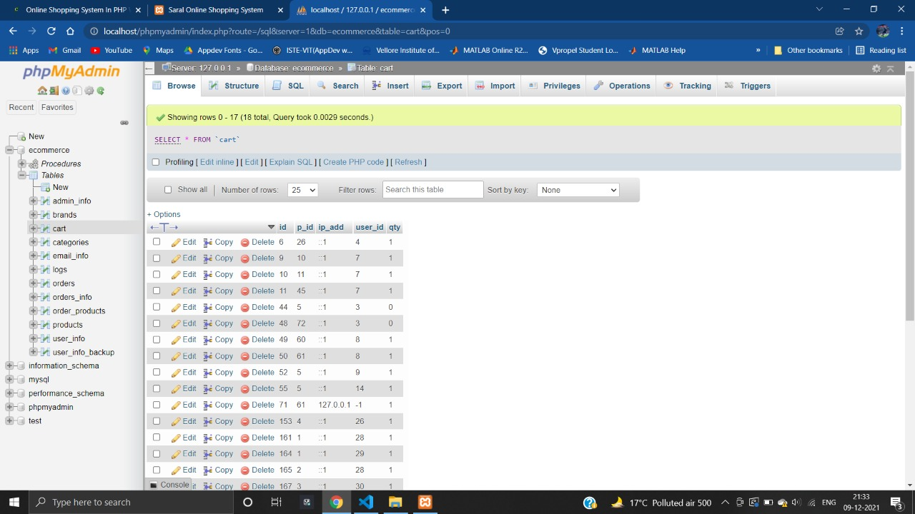

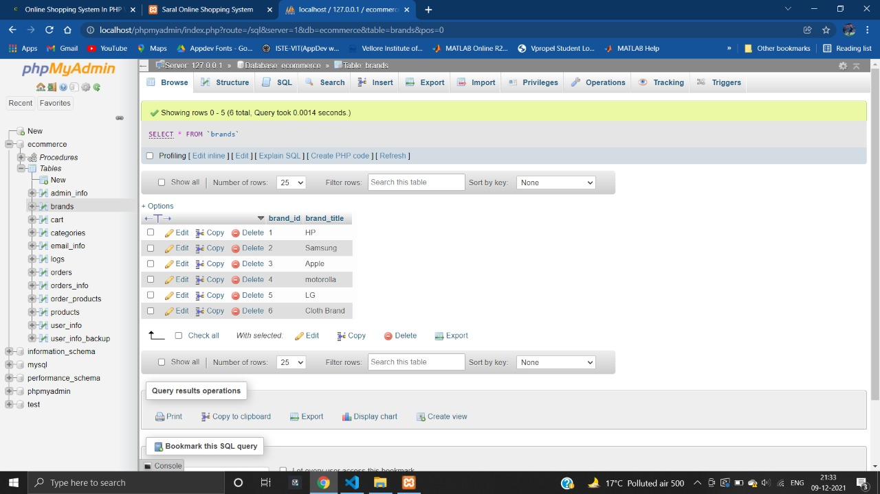

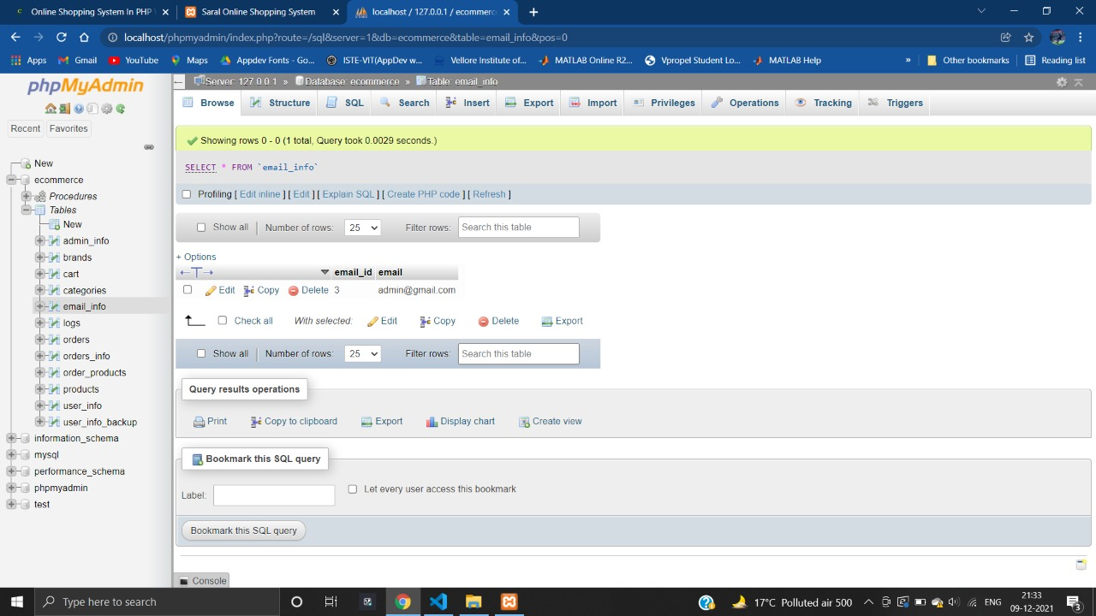

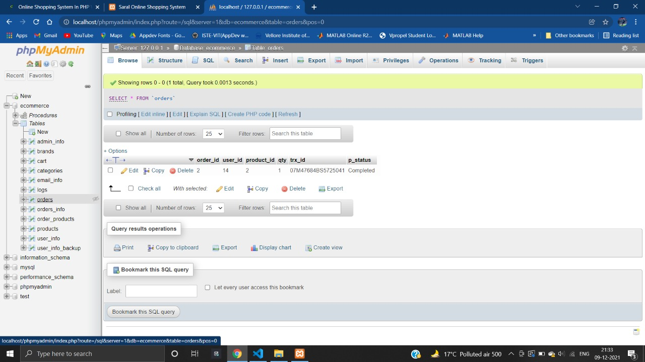

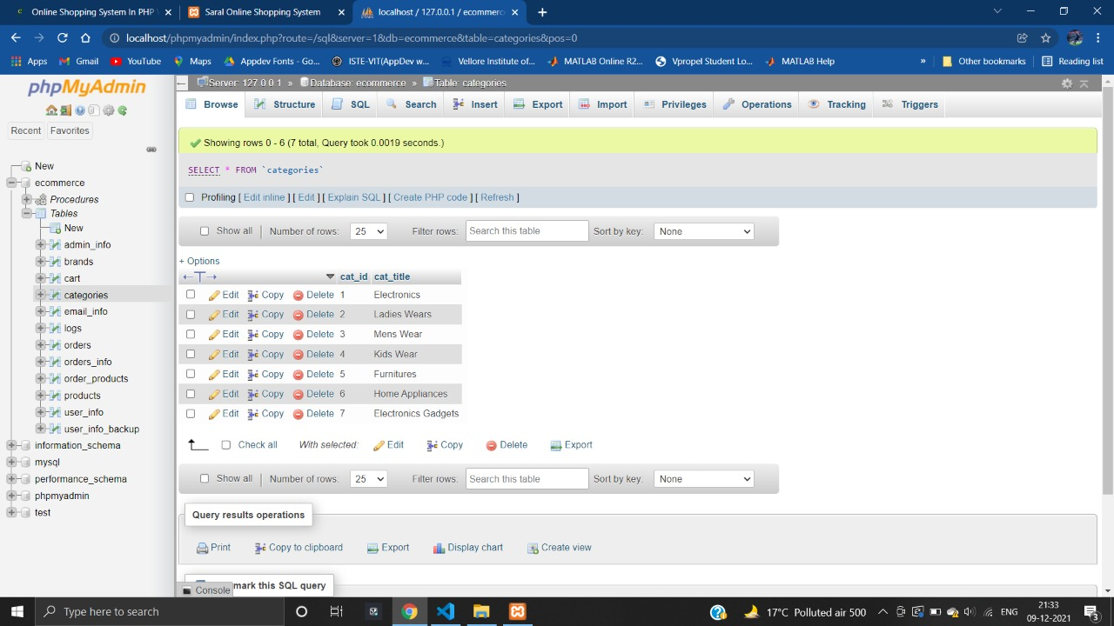

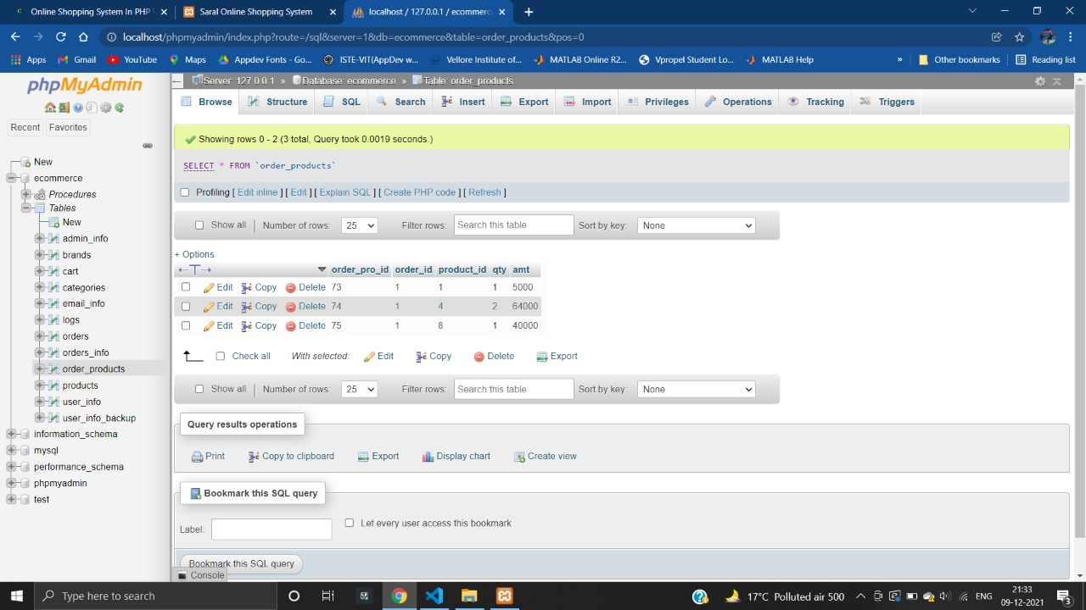

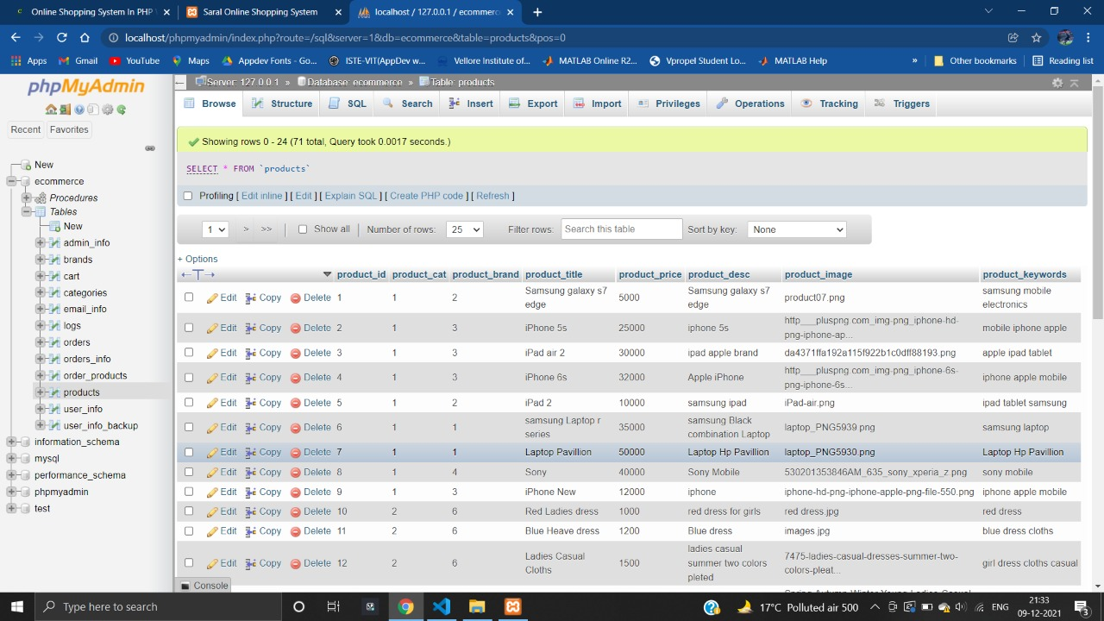

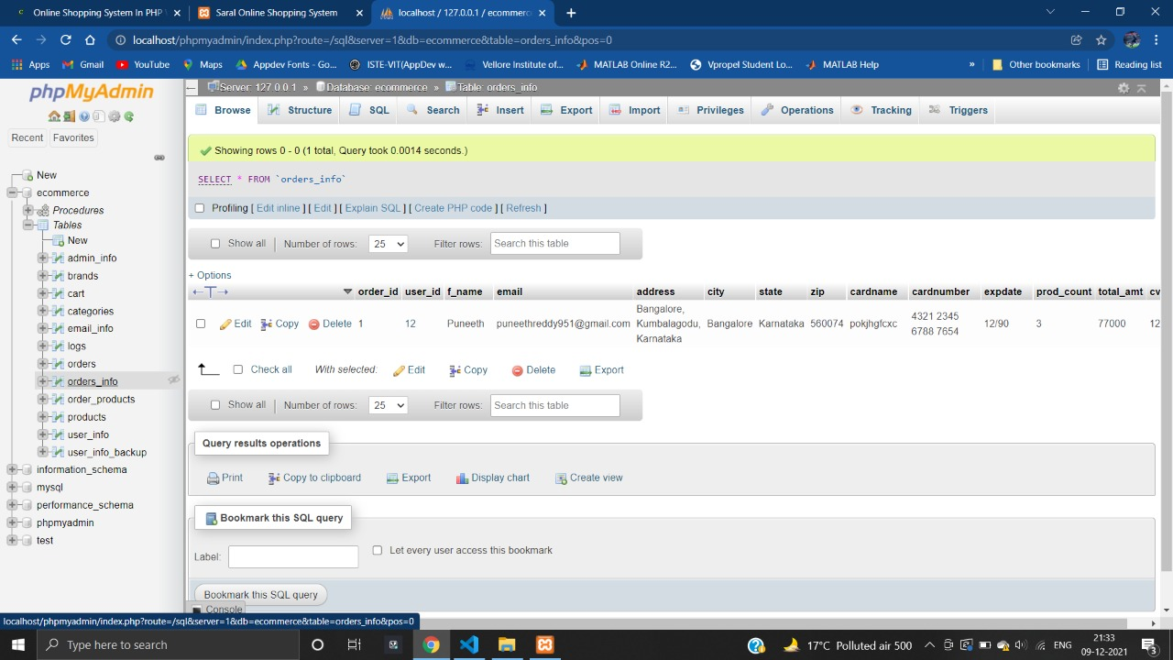

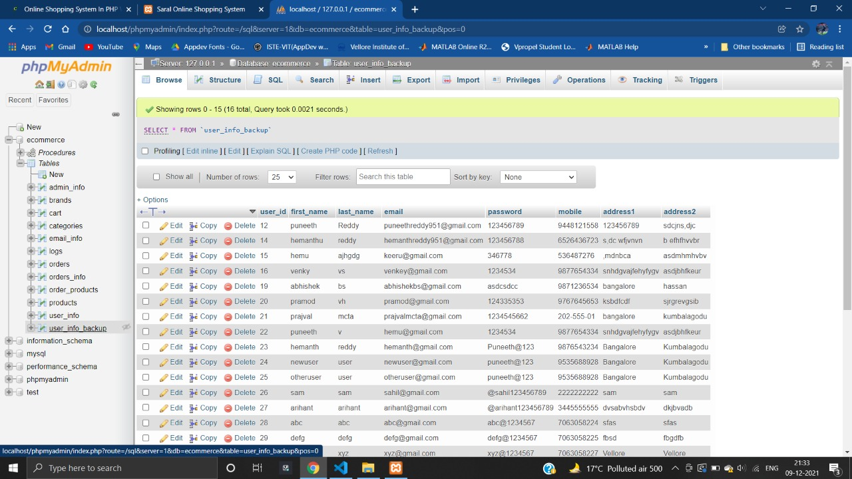

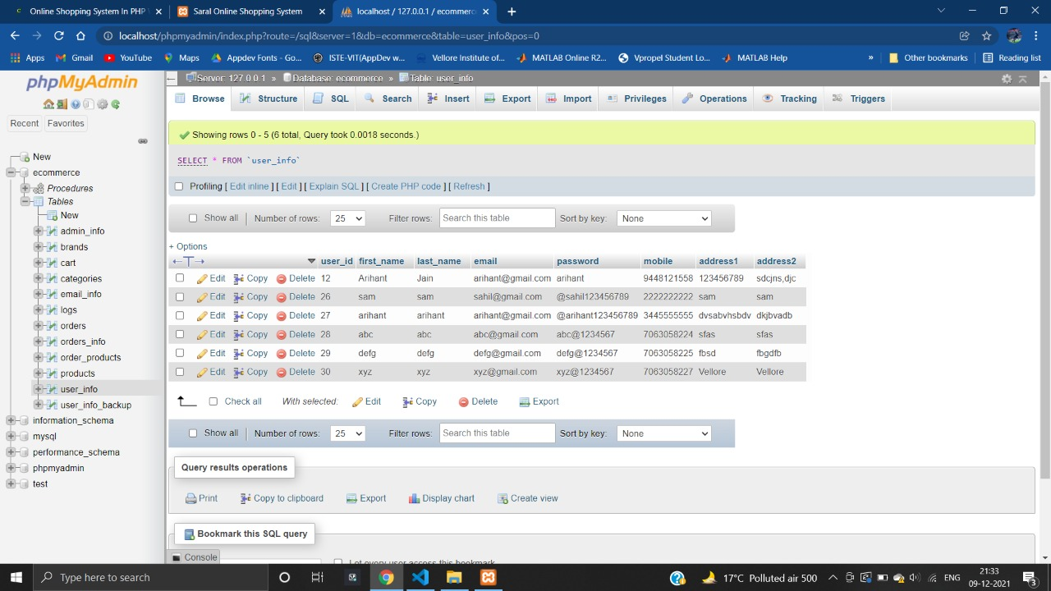

**Related Screenshots**

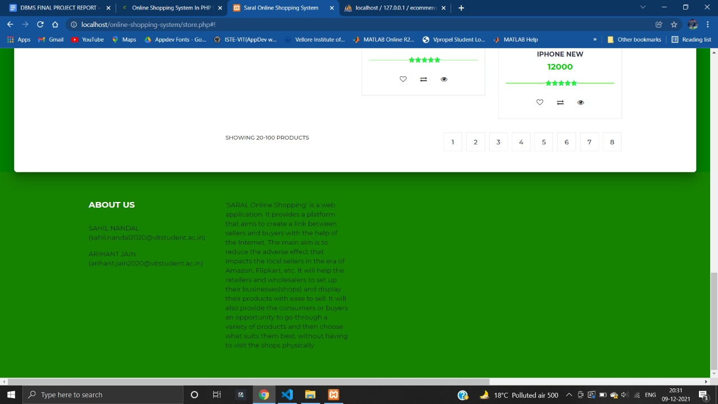

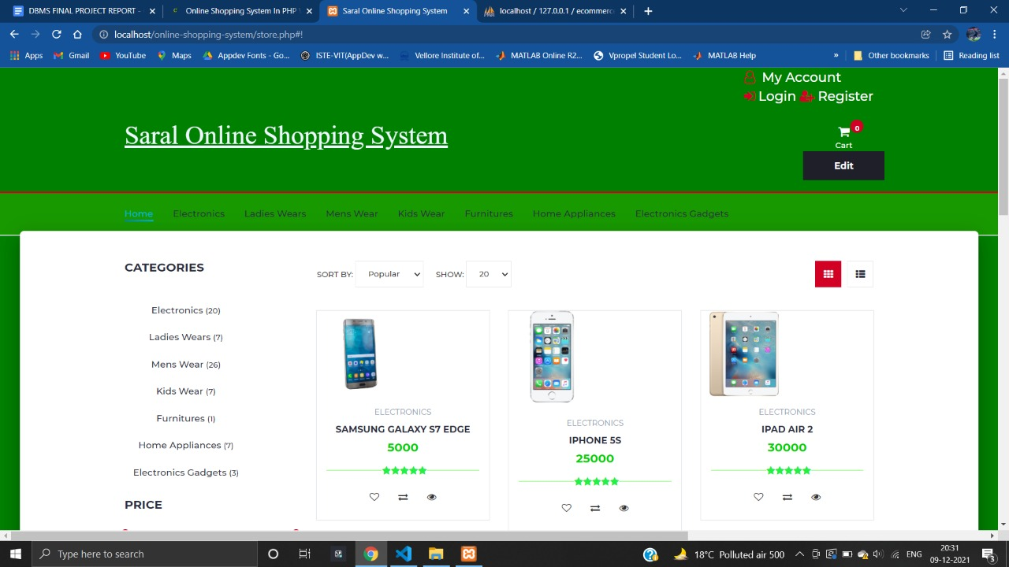

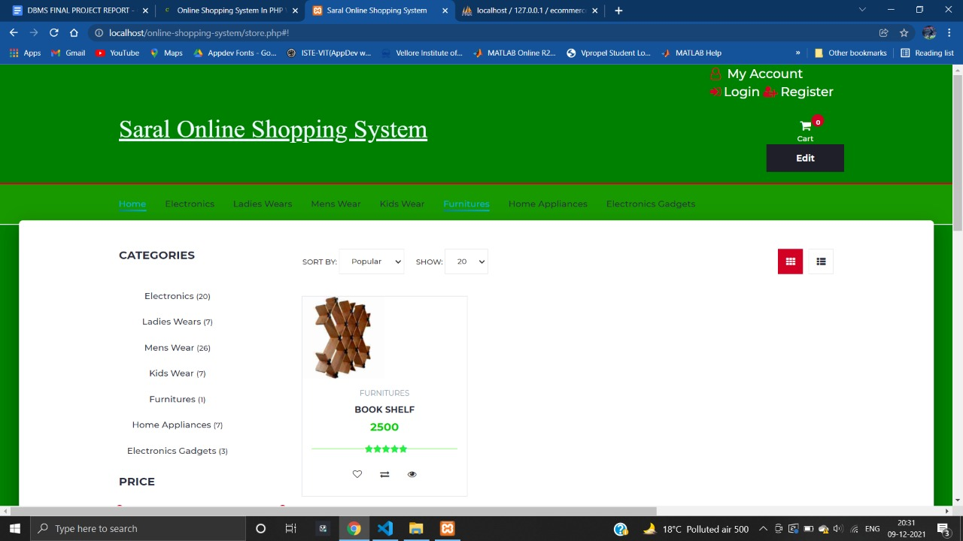

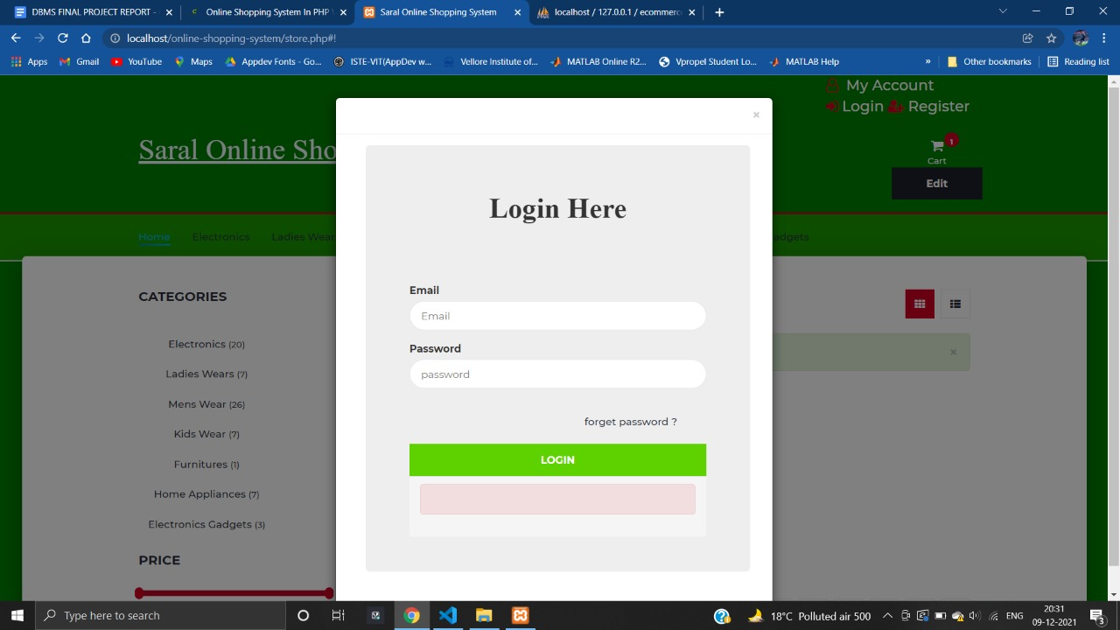

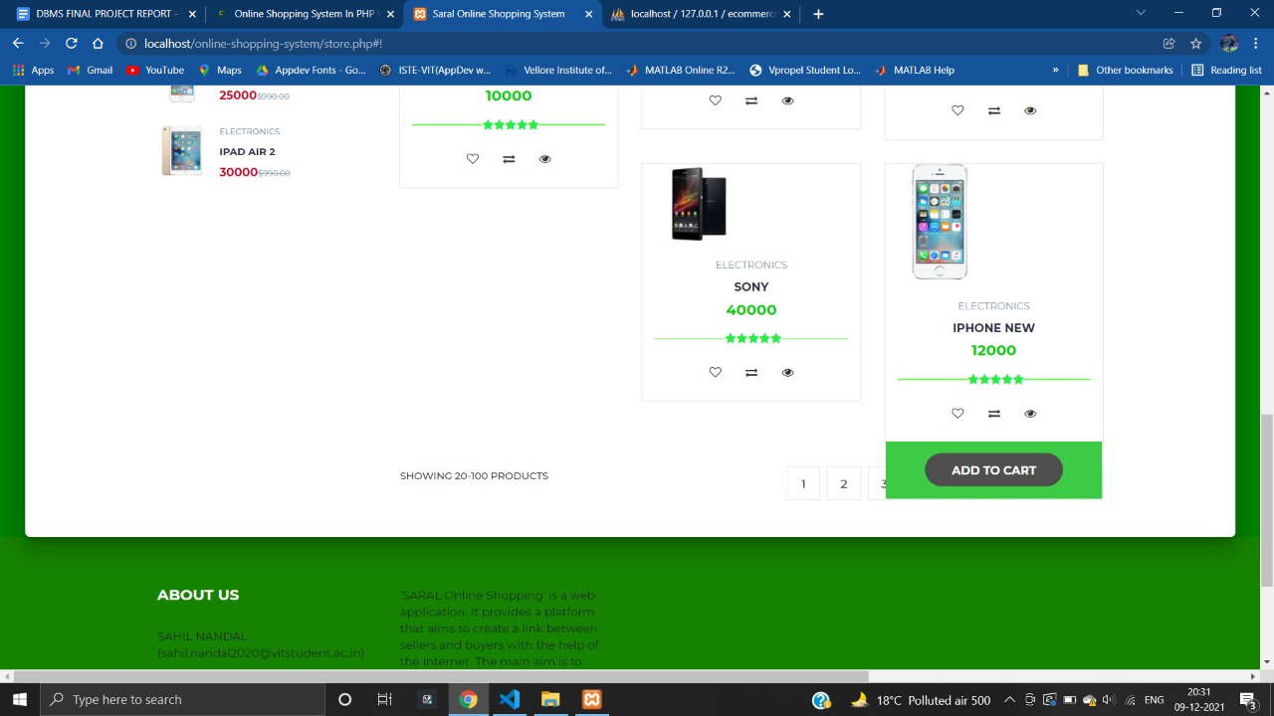

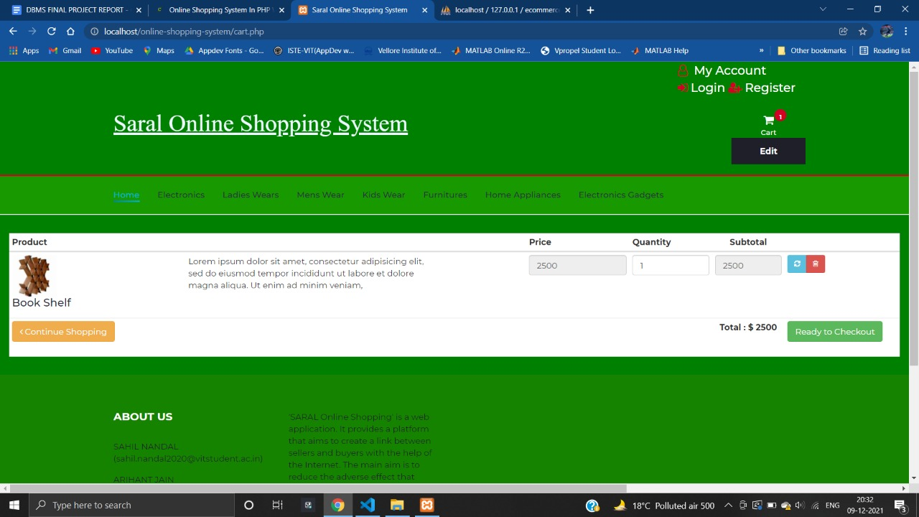

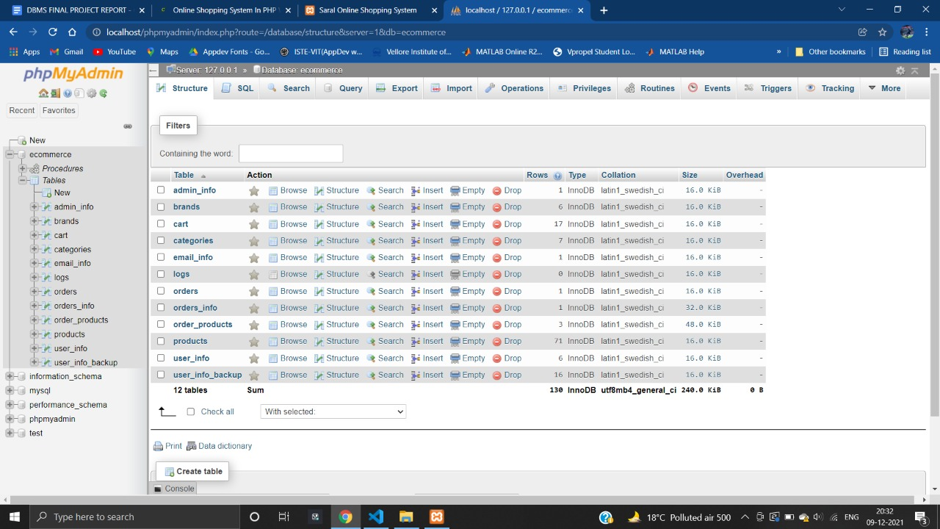

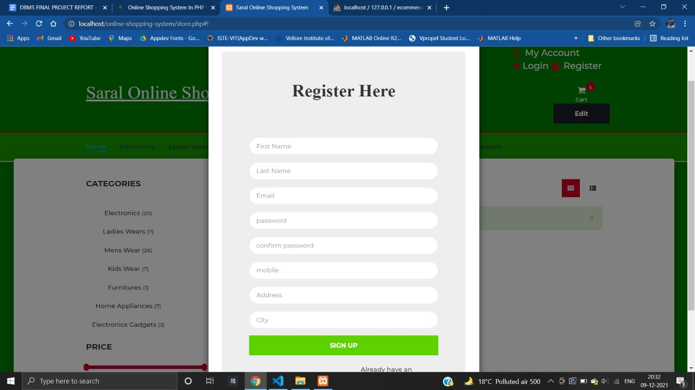

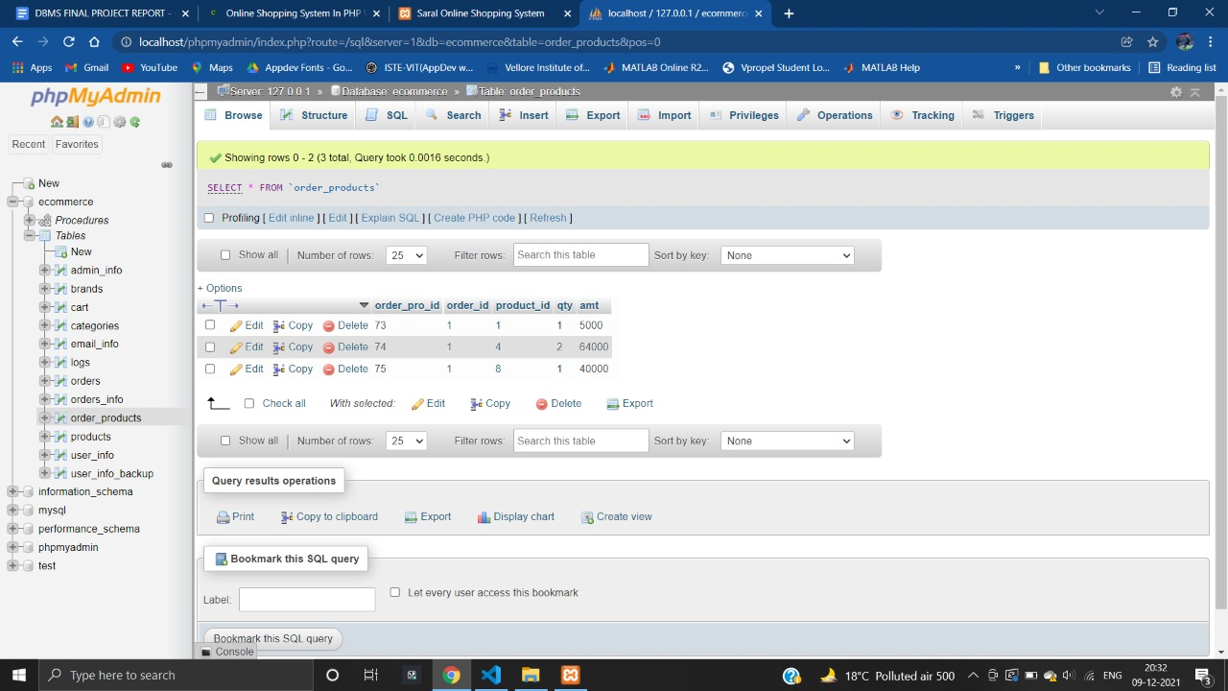

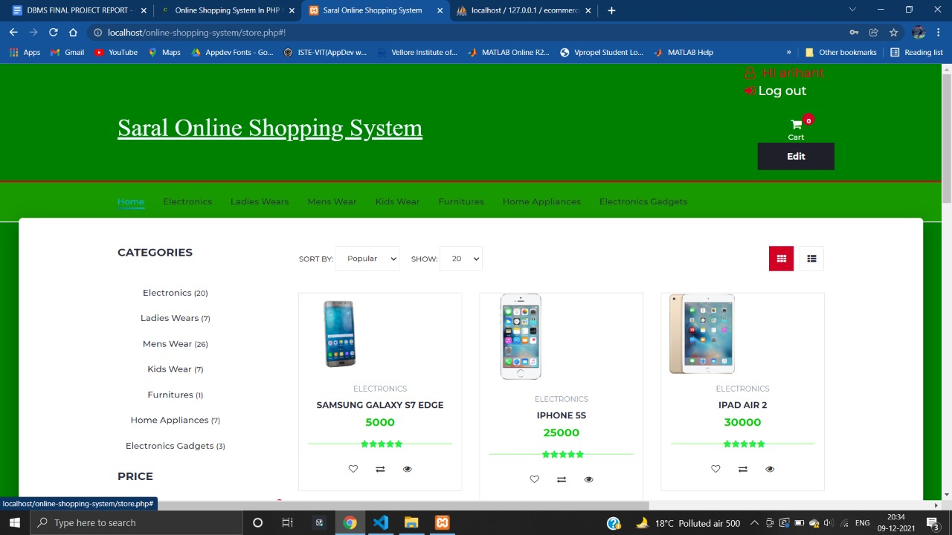

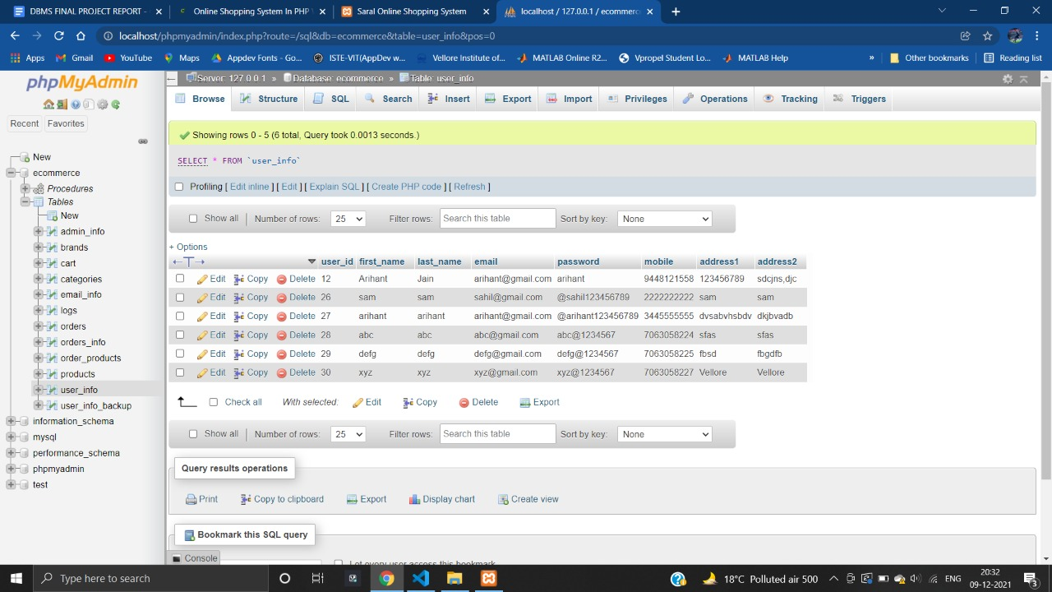

**Bibliography**

We have used various websites for searching and also learning. Some of the references are mentioned below-

* <https://www.google.com/>
* <https://www.w3schools.com/>
* <https://www.php.net/>
* <https://www.oracle.com/in/index.html>
* <https://stackoverflow.com/>
* <https://www.geeksforgeeks.org/>
* <http://codereaper.com/blog/>
* <https://www.youtube.com/>
* <https://app.diagrams.net/>